Designer Children's Clothes Emerge Featuring Whimsical Charm
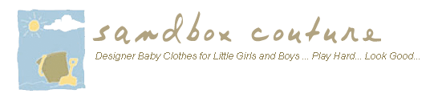

Released on: February 26, 2008, 11:46 am
Press Release Author: Sam Brown/ Sandbox Couture
Industry: Retail
Press Release Summary: Baby Clothes & Children's Clothes Retailer Notes Rising Fashion Trends
Press Release Body: Rancho Santa Margarita – CA February 26, 2008 – Sandbox Couture, a popular online children's boutique retailer of baby clothes, childrens clothes and baby gifts today announced rising trend of children's clothes following charming patterns and styles of whimsical appeal.
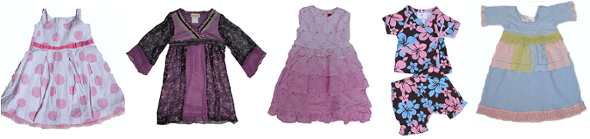
Many children's clothing brands this season boast the idyllic fashions with soft tones of pinks, reds, blues and yellows as seen in the Asian inspired designs of Mad Sky Infant Kimono Sets. Designers are also pulling from the seventies, combining tye-dye with newer, edgier imprints of current tribal like patterns. The hard rock meets outdoor garden fashions are quite popular in the pre-teen and children's sizes. For infants and babies, hot ticket items include Jack and Lily Baby Shoes, Baby Sara among others.
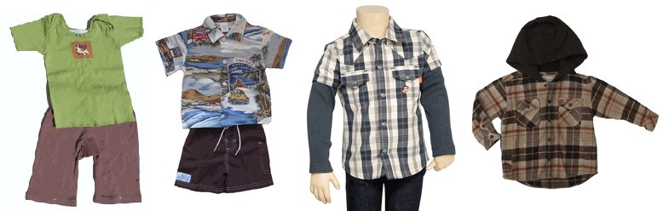
"This season offers fantastic designs for childrens clothes and baby clothing fashions," stated Sam Brown, spokesperson for SandBoxCouture.com. With the influences of previous decades combined with the latest techniques and trends of today, designers are producing creative looks for children's clothes that are fresh, edgy yet with a charismatic appeal. "We've seen a recent spike in items featuring designs centered around whimsical charm," said Brown.
Sandbox Couture features boutique offerings such as Flowers by Zoe, Biscotti, Mad Sky, Roxy, Lipstik and Tony Tierney, to name a few. In addition to children's clothes, the couture retailer also provides the latest designs in baby clothes as well as adorable and practical baby gifts.
The popular online boutique provides must have brand names in baby clothes, children's clothes and baby gifts. Offering a huge selection of designer clothing perfect for baby shower gifts, birthday gifts, newborn celebrations or other special occasions, Sandbox Couture provides shoppers convenience, unique apparel and fashion savvy style. For more information, please visit http://www.sandboxcouture.com.
Web Site: http://www.sandboxcouture.com
Contact Details: Press Contact
Sam Brown
949-459–2505
pr@sandboxcouture.com

