Estee Lauder launches new limited edition Mother’s Day gifts


Released on: February 22, 2008, 7:13 am
Press Release Author: Estee Lauder
Industry: Consumer Services
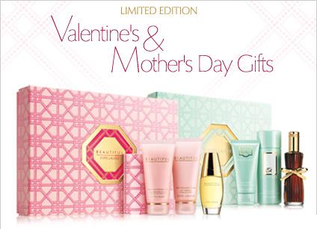
Press Release Summary: Estee Lauder, a leader in the luxury cosmetics, skincare and perfumery market, introduces new limited edition Fragrance Gift Sets in time for Mother’s Day
Press Release Body: Estee Lauder, a leader in the luxury cosmetics, skincare and perfumery market, has introduced 8 new limited edition Fragrance Gift Sets for Mother’s Day.
The perfume gift sets encompass each of Estee Lauder’s most popular fragrance lines, and are all available from the Estee Lauder website. Included in each set is an Eau de Parfum, along with accompanying body products, which are all gift wrapped and ready for this Mother’s Day.
The Estee Lauder Mother’s Day lineup includes perfume gift sets for Pleasures, Pleasures Delight, Beautiful, Beautiful Love, White Linen, Pure White Linen, and Youth-Dew.
The complimentary gift-wrap service ensures the fragrance sets are received beautifully wrapped, and presented with a gold bow and gift card. A tip to make the gift more personal is to leave the gift card blank, so that you can fill it in by hand when you receive it.
However, if fragrance isn’t her thing, there are many more Mother’s Day gift ideas available on the Gift Finder that allows customers to browse and buy gift ideas by category, price bracket and recipient.
For the thousands of visitors the Estee Lauder site receives every day, the cosmetics giant also provide a number of free advice guides from International Makeup Artist, Alan Pan, including a foundation application guide, an eye shadow application guide, a brush guide, and a skincare regime guide. There is also an interactive online Skin care Consultation, to take customers through their individual skin regime.
About Estee Lauder
In 1946, Estee Lauder started business with one face creme, and the desire to bring out the beauty in every woman. By the time the revolutionary fragrance Youth-Dew was introduced in 1953, the Estee Lauder Company had already won a reputation for innovation, research and quality.
Now Estee Lauder's skincare, makeup and fragrance collections exemplify the best that technology, science and arts can achieve. The Estee Lauder name on a product is recognised in over 100 countries for quality and has gained a worldwide reputation for elegant, and luxurious products that uphold the finest standards of excellence through extensive research and stringent product testing.
The Estee Lauder Companies’ annual Breast Cancer Awareness Campaign involves all of the 18 brands that make up The Estee Lauder Companies. They collectively represent The Breast Cancer Research Foundation’s first and largest corporate supporter. Estee's daughter-in-law was the creator of BCRF's signature pink ribbon. Over $10 million has been raised for The Breast Cancer Research Foundation since 1993. Another $1 million was raised from their retail partners since July 2002.
Web Site: http://www.esteelauder.co.uk/home.tmpl
Contact Details: PR contact:
Brona McCafferty
Estee Lauder
73 Grosvenor Street
London
W1K 3BQ
08700346911

