For Sale: Most Expensive Apartment in Bulgaria, say Eurosilex


Released on: February 27, 2008, 2:52 am
Press Release Author: Albena Karakoleva
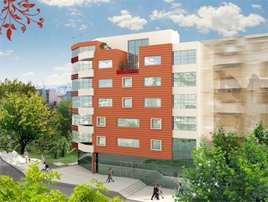
Industry: Real Estate
Press Release Summary: Eurosilex, a specialist in residential and mixed use property development in Bulgaria, has announced the availability of the most expensive apartment in Bulgaria, valued at 1.2M Euros
Press Release Body: Eurosilex, a specialist in residential and mixed use property developments, has just announced the availability of the most expensive apartment in Bulgaria.
The luxury penthouse property is situated in the charming city of Varna, and is being offered for sale by Eurosilex, priced at 1.2M Euros. Varna is Bulgaria's largest city on the Black Sea coast and is currently experiencing a period of expansion with demand for new homes rising sharply. The new property is part of the Kavala Street development, which offers a total of 19 luxury apartments, with 17 parking spaces, an office and a snack bar. Construction started in April 2007 and is scheduled to be completed by December 2008.
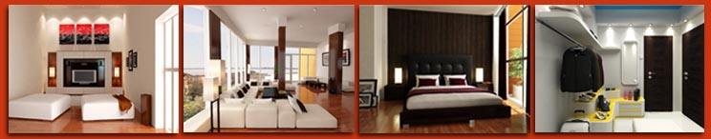
The luxury penthouse apartment is a state of the art property, offering a bespoke design and high class living. With a total area of 553.35 square meters, spread across two floors and an outdoor terrace, the luxury apartment has ample room for a family, plus plenty of space for entertaining.
The apartment comes as an empty shell with only the external walls in place, meaning it is a blank canvas which can then be custom fitted to suit any taste, however extravagant. An example of the possible final product is viewable on the Eurosilex website, which shows the apartment fitted with a large reception room, a spacious dinning room and lounge with floor to ceiling windows, fully equipped kitchen, a large terrace with wood decking and a hot tub spa which overlooks the city and the sea. It also shows two double bedrooms, a walk-in wardrobe, a lavish luxury bathroom, two children's bedrooms, a shower room with glass power shower and a kids' playroom. The example apartment is furnished to the highest luxury standards throughout, with futuristic electronics wired in, and showcases the level of luxury that could be applied.

For anyone looking for a luxury property overseas, Bulgaria's Kavalar development offers the perfect location; it's situated near the pedestrian city centre close to shops, restaurants, bars, financial institutions, administrative centres, offices, a post office, hospital and school. It is also close to the main road leading to Varna international airport, the railway station and the bus station, meaning convenient access to the rest of Bulgaria and abroad. The apartment building itself is located in a quiet region amongst private houses and small apartment blocks and is close to the famous Golden Sands and Albena beach resorts.
A spokesman for Eurosilex commented:
"We are delighted to be offering what must be one of the most extravagant pieces of property in Eastern Europe. The penthouse Kavala Street apartment is the absolute pinnacle of luxury living and is perfectly situated in a charming area of Varna on the Black Sea coast. At 1.2M Euros, this is the most expensive apartment in Bulgaria and will suit a buyer who is looking for an extremely high quality and decadent property in Bulgaria in a superb location".
About Eurosilex
Eurosilex specialise in residential and mixed use property development in Bulgaria. They offer the full range or property buying services, tailored specifically for British and other international buyers[U3], including a dedicated sales team, mortgage assistance, after sales solutions, resale services, rental services and legal advice.
Eurosilex have offices in Varna and Bansko as well as representative offices in London, Paris and Moscow[U4]. The multilingual Eurosilex website [U5]also offers a buyer's guide, general information about regions of Bulgaria, Bulgarian financial information as well as special property offers.
Web Site: http://www.eurosilex.com/
Contact Details: Eurosilex PR Contact
Albena Karakoleva
Property Developer
15 Ruse Street
Varna 9000
Bulgaria
0871 222 3355
http://www.eurosilex.com/

