H.Samuel keeps love secret this Valentines Day


Released on: February 4, 2008, 6:33 am
Press Release Author: H.Samuel
Industry: Retail
Press Release Summary: H.Samuel offers a free Secret Valentine online service to add a little extra spice to Valentine’s gifting
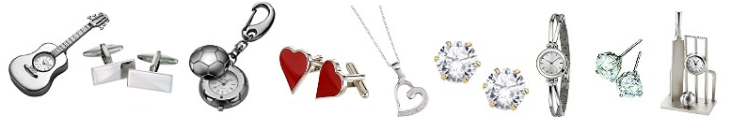
Press Release Body: In the approach to Valentines Day, an occasion when lovers can truly express their feelings for each other, H.Samuel is aiming to put the excitement back into the giving of Valentine’s gifts, making it as mysterious and sexy as possible.
H.Samuel the jeweller, is offering a free anonymous gifting service for all Valentine’s Day gifts, in an effort to add a frisson of excitement into the act of giving Valentine’s presents this year. All online purchases in the run up to Valentine’s Day will carry the option of sending the gift anonymously, resurrecting the tradition of sending secret Valentine’s gifts. H.Samuel is the only online jeweller to offer a free anonymous sender option.

When customers purchase any collectible, watch or item of jewelry from the website, they will be offered the option of choosing from three pre set messages to tease the object of their desire, or they can write their own short custom message to be included with the gift., this means that when the object of the purchasers affections receives the gift they will find it tantalisingly mysterious.
To make the choice of what to buy easier, H.Samuel has created a new Valentines Day gift ideas section on their site, filled with collectibles, engravings, romantic gifts, jewelry and watches, all ideal for that special someone.
For those romantics not looking for mystery, but rather wanting to express their love to the world by getting engaged over Valentines, H Samuel is also offering a number of prizes to customers who purchase one of their Forever Diamonds rings. This includes the chance to win £5,000 towards their wedding and the announcement of the engagement in OK! magazine.
The Secret Valentine service will be offered to all customers buying anything online from www.hsamuel.co.uk until Valentine’s Day.
About H Samuel
As the nation's favourite jeweller with 375 UK stores, H.Samuel stocks a comprehensive collection of jewellery, branded watches, collectibles and original gift ideas. H.Samuel is part of Signet Group plc, the world's largest speciality retail jeweller.
Notes to editors:
- Every order from the website www.hsamuel.co.uk qualifies for the Secret Valentine
- The service is free
- Free messaging included
Signet will not disclose the sender's personal details, unless a formal or official request is received from either the recipient or relevant authorities.
Web Site: http://www.hsamuel.co.uk/
Contact Details: For more information contact:
Lloyd Anthony
e-Commerce Trading Manager
Signet Trading Ltd
Imperial Place
3 Maxwell Road
Borehamwood
WD6 1JN
0208 207 8319

