International media planning and buying - and the perils of DIY


Released on: February 11, 2008, 5:03 am
Press Release Author: Richard Fox, Managing Director, Fox Media
Industry: Advertising
Press Release Summary: The internet has made it much easier for advertising clients to book their own media space and airtime - but there are very good reasons to think twice about doing so ...
Press Release Body: With the information superhighway nowadays linking all parts of our global media village, in theory it should be easy for anyone to plan and buy international media campaigns effectively. Clearly the internet is making it much more straightforward for clients to find the information they need and access media direct, right around the world.
But in the reality of this brave new worldwide arena, international media planning and buying is no less hazardous for the unwary and inexperienced than it was in days of old. Just because finding the contact details of foreign media has become simply a matter of typing a few words into Google, that doesn’t mean the trapdoors and ambushes have suddenly been spirited away.
In media, the buyer should always beware: but when an inexperienced client is tempted to engage in a bit of DIY media buying at the international level, the chances of a painful outcome can be greatly multiplied.
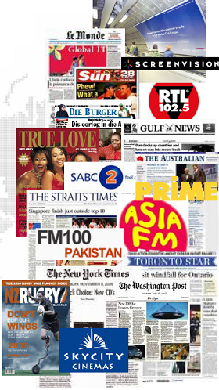
The fact that international buying tends to be more complex has implications for lead times, for instance. Whilst multi-country media campaigns can be executed quickly and efficiently by agencies with the right media specialisms, clients who attempt to do the job themselves will often underestimate the cumulative effects of differences in booking protocols and terminology, variations in rate card structures, language obstacles - even the way national holidays can impact on short term buying - and a host of other factors.
Last minute media buying is great if you're in charge of the situation - but if the 'distress purchase' is being made by someone who should have got their act together earlier, costs will inevitably soar.
Budgeting is another media job that is often bodged by the DIY client. The media budget for an international campaign needs to incorporate a greater degree of flexibility than the budget for a single country campaign. For a campaign of any sizeable duration, it's really important to build into the media plan a larger reserve, ensuring that adjustments can be implemented to take account of currency volatilities, sudden massive increases in media costs (as has been happening in Russia, for instance) and unexpected pan-continental expenditure 'spikes' by competitive brands.
The temptation to impose a 'one size fits all' media solution across a number of different territories is also a common mistake. And this is not confined to DIY-inclined clients: quite often it represents a useful 'quick fix' that a rogue agency can use to cut their own labour costs.
Just as the over-zealous imposition of consistent creative executions worldwide can have unfortunate consequences at the local level, so too the use of broadbrush media planning for international campaigns can erode the return on a client's investment in international media.
It's all too easy for a client to consent to the selection of the same media and media formats being utilised across all the countries on the plan - when what is really needed is a 'media neutral' approach in which a strong, overarching planning and buying strategy is carefully adapted to the idiosyncracies of each country's media profile.
Of course, for the inexperienced client, doing international media buying can be fun - until things go wrong and the accidents start to happen. Arriving on the scene of a campaign that's been put together by someone without the necessary skills, understanding and resources can be a salutary experience. Sometimes the media plan can be patched up - more often it's a case of dismantling the whole thing and starting again.
And whilst one can understand why and how these media accidents can happen, for many DIY clients the same old rule applies - they should probably have left it to the professionals …
Web Site: http://www.ukmediabuying.co.uk/international.htm
Contact Details: Person to contact
Richard Fox,
Managing Director
Telephone
+44 (1) 354 740916 (from outside the UK)
01354 740916 (from UK)
Address
Fox Media Company Limited
Huntingdon Business Centre
Blackstone Road
Huntingdon
Cambridgeshire
PE29 6EF
England
e-mail
rf@foxmedia.co.uk

