Tracesmart seeks missing persons


Released on: February 22, 2008, 2:30 am
Press Release Author: Tracesmart Ltd
Industry: Internet & Online
Press Release Summary: Tracesmart has announced that they are to provide searchers with an opportunity to find missing persons for free
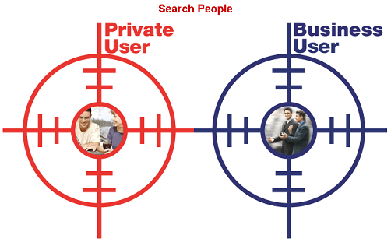
Press Release Body: Tracesmart is the UK’s premium online people search facility and over the years has been instrumental in reuniting thousands of lost family members and friends. Now Tracesmart has announced that they are to provide searchers with an opportunity to find missing persons for free.
Tracesmart is currently offering an opportunity to complete a missing person search free of charge in exchange for the story being shared exclusively with Tracesmart in the media. Tracesmart could also financially support face to face reunions for high profile cases.
Owen Roberts, Tracesmart’s Communication Manager, commented, “We intend to highlight very newsworthy stories so there will need to be a special reason for us to feature the reunited individuals. We envisage commemorating a high profile get-together with free hotel accommodation and champagne reception to celebrate the reunion, so this really could be a fantastic opportunity”.
“Tracesmart really could change a person’s life forever, all searchers need to do is complete the online missing person application form and we could reunite long lost friends or family members within days”, Owen added.
Further information about this offer is available on the recently improved Tracesmart website where the enhanced features now make it even easier to locate a missing person online. The user friendly site will help assist even more customers in their people search using frequently updated electoral roll, postcode and land registry databases. Owen Roberts stressed, “We are very customer focused within Tracesmart, striving to enhance the end-user experience and to continuously improve our navigation system and powerful search engine technology, and we are now seeing significant growth in customer numbers”.
About Tracesmart
Founded in 1999, by a group of experienced people tracing experts and professional genealogists, Tracesmart Ltd has since its launch become one of the most widely used people search tools in the UK. Its modern Cardiff based headquarters is at the vanguard of web based technology and also offers a variety of services to the corporate sector as well as to the general public. Office space in Cardiff Bay will double within the month to accommodate Tracesmart’s rapid expansion plans.
Tracesmart now has over 250,000 registered users and over 750 business clients. Currently over 10,000 people searches are performed on Tracesmart each day.
Web Site: http://www.tracesmart.co.uk/
Contact Details: Tracesmart Press Contact:
Owen Roberts
Communications Manager
Tracesmart Ltd
2 Sovereign Quay
Havannah Street
Cardiff
CF10 5SF
029 2047 4117
http://www.tracesmart.co.uk/

