Ascent Adventure Consultants: Building into the Stability and Success of Raleigh NC Businesses
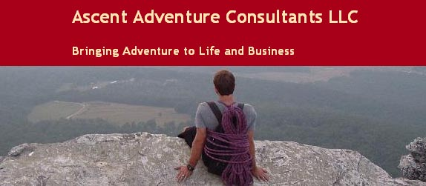
Released on: March 18, 2009, 5:25 am
Author: Brandon Hensinger
Industry: Management
Ascent Adventure Consultants, Apex North Carolina based corporate team building experts and professional rock climbing guides, have created two unique team building programs that are designed to build confidence, stability, loyalty, unity, success, and ultimately profitability into the businesses in the Raleigh, Durham, and Chapel Hill area.
The two programs are titled Summit Team Building, and Excursion Team Building. Summit Team Building programs are programs full of interactive, experiential team building initiatives that have been customized to meet the business’ goals and desires for the program. Excursion Team Building programs are held off site as a weekend retreat in which participants travel to the mountains, either staying in a hotel or camping, and participate in rock climbing and other outdoor adventures as a mean of team building.
“Ascent Adventure Consultants has a unique approach to their team building sessions. Their passion for helping people challenge themselves is refreshing and will serve both managers and employees alike. I would highly recommend them if you want your staff to think beyond the obvious and become more creative and critical thinkers,” expresses Mark Davison, an Ascent Adventure Consultants’ course participant.
The Ascent Adventure Consultants website explains these programs in full detail. Please visit http://www.ascentadventure.com.
If you are interested in writing or speaking about these programs, or for more information, please contact Brandon Hensinger, at Ascent Adventure Consultants: bhensinger@ascentadventure.com or 919-345-1087.
Ascent Adventure Consultants, based in Apex North Carolina, provides individuals and businesses with a dynamic way to break free from their normal routine and everyday experiences and accomplish something that seems out of reach, by offering customizable corporate team building programs, as well as professionally guided rock climbing and mountaineering adventures, They are committed to equipping every business with the tools it needs to achieve its goals and to guiding every individual on an incredible adventure.
Contact Details: Apex NC
919-345-1087
bhensinger@ascentadventure.com
http://www.ascentadventure.com

