Check Gallery is now featuring Lisa Jane’s Fairies on personal checks


Released on: March 10, 2009, 7:27 am
Author: Stephanie Demetriou/Check Gallery
Industry: Marketing
Check Gallery is America’s earth-friendly check printer. Because it prides itself on this fact, Check Gallery offers a vast assortment of check designs and banking accessories that appeal to the tastes of nature lovers and “green” consumers. The new “Lisa Jane’s Fairies” design gives an imaginative feel to the forest that is sure to catch the admiration of many Check Gallery customers.
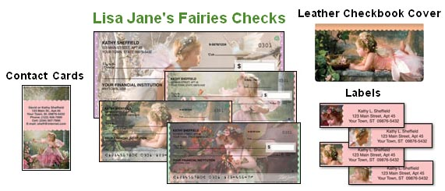
For nearly twenty-five years, Lisa Jane’s creative talent and distinctive styles have earned her almost every degree and honor in professional photography. However, the artist simply sees her work as the ability to “capture a moment in the life of one tiny soul and keep it forever in a photograph.” Check Gallery is very excited to offer the work of such an insightful and talented artist to its consumers.
In early March, 2009, Check Gallery released the new “Lisa Jane’s Fairies” product suite on its website, www.CheckGallery.com. In four rotating scenes, the personal checks portray toddler girls dressed as beautiful fairies surrounded by blooming flowers, butterflies, bunnies, and birds. The self-adhesive address labels show the same young girls, but only their angelic faces against pink backgrounds. For the checkbook cover and personal contact cards, only one small fairy is featured with a border and backdrop to match her dress and wings.
Check Gallery’s designs have always spoken to a naturalistic audience. In these fairy tale photographs, customers not only get to enjoy a beautiful landscape, but great photography and adorable little fairies as well. “Lisa Jane’s Fairies” is a wonderful new addition to the Check Gallery collection. Visit the site to view this or another design that you are sure to enjoy.
About Check Gallery:
Known for being environmentally-friendly, Check Gallery has been printing and selling checks and check accessories direct to consumers for years. With a vast selection of beautiful designs and useful products, Check Gallery really has something for everyone. Plan a trip to this site and you are sure to find something that will peak your interest!
Contact Details: 1802 Fashion Court
Joppa, MD 21085
410-679-3300 ext. 2453
410-676-3300 (Fax)
sdemetriou@cdi-us.com
http://www.CheckGallery.com

