Click Consulting Announces Referral Partner Program
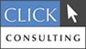

Released on: March 9, 2009, 6:27 am
Author: Click Consulting
Industry: Computers
IT and web development services firm pays 5% residual commissions on referrals for 1 year period
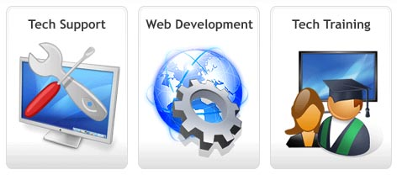
Irvine, Calif., March 6, 2009 -- Click Consulting announced the launch of its Referral Partner Program. After a few months of testing with selected partners, Click Consulting has found the arrangement to be valuable for both the company and its partners, and is ready to accept new applicants for the program.
The Referral Partner Program allows the partners of Click Consulting to sell their products, notably managed services, IT consulting, computer consulting, and web development services, and receive a 5% commission. Unlike other programs however, the 5% is not a one-time payment. The Click Consulting Referral Partner Program allows their partners to receive 5% of all services rendered to the referred client for an entire year (with a few minor exceptions). The partners only have to sell one time and they receive commissions for an entire year on anything Click Consulting sells the new client.
Click Consulting is a full services IT and Web Development services firm that provides Tech Support, Web and Application Development and Training. Tech support encompasses all of an organization's computer related issues, including network support, help desk, server support, remote access, servers, Exchange servers, Blackberry servers, backup, email defense and more. Web and application services include website design and production, web applications, intranets, extranets, client portals, interactive sites, ecommerce sites, CMS sites, open source web applications, databases, Excel spreadsheets, Access databases, SQL servers, application integration, shopping carts. Click Consulting provides training on range of technology topics, including Microsoft Office, small office networking, email security, remote access, firewalls, server configurations and more
If you wish to be part of the Referral Partner Program, simply contact Click Consulting for more information or visit us online atwww.clickconsulting.com.
About Click Consulting
Click Consulting is a full service IT and Web Development company based in Irvine, Calif. Focusing on small and growing companies, Click provides remote IT support, on-site tech support, self-managed websites, and fully custom web projects. Trusted by industry leading companies to manage their business critical networks and applications, Click Consulting specializes in Tech Support, Web Development and Computer Consulting. For more information, please visit www.clickconsulting.com.
# # #

Contact Details: Cody Boyte
Click Consulting
www.clickconsulting.com
866-207-9426

