Connecticut Drug Rehab Mountainside announces that it has treated more than 5,000 people suffering from drug addiction and alcoholism

Released on: March 31, 2009, 8:20 am
Author: Mountainside Drug Rehab
Industry: Healthcare
Connecticut Drug Rehab Mountainside announces that it has treated more than 5,000 people suffering from drug addiction and alcoholism.
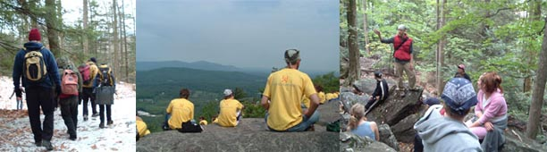
Mountainside Drug Rehab in Canaan CT has announced that more than 5,000 people have been treated for addiction and alcoholism at its inpatient drug rehabilitation center in a little over the 10 years of operations. The people entering treatment at this serene inpatient center have ranged in age between 18 years and 82 years of age, with the average age being approximately 31 years of age.
The residents of Mountainside Drug Rehab have come from all over the world, with some traveling as far as Thailand and India. However, the majority of residents entering the treatment center for drug rehabilitation and alcoholism come from the United States and from Canada. Mountainside Drug Rehab forecasts that its drug treatment program will help more than 500 people this year, with the majority coming from the United States.
A growing number of residents entering treatment have come from Florida and California. Due to the continuing number of residents from Florida and California, Mountainside has announced plans to open alumni aftercare centers in Mariana Del Ray, Los Angeles in 2009.
Mountainside’s individual drug rehab program has resonated with people and their families across the globe because of its quality program and affordable price. Built on compassion and driven by the thesis that no two people are identically alike, Mountainside tailors individual drug addiction treatment plans for every person that enters Mountainside Drug Rehab. Taking variables into account such as substance abuse history, various psych-social criteria and addiction treatment goals and timeframes - addiction treatment plans are carefully designed, monitored and also changed when the goals change.
Drug Rehabs across America are faced with the challenge of providing effective and quality treatment. Mountainside Drug Rehab has met this challenge for the past eleven years and has renewed its commitment to provide compassionate and quality drug rehabilitation.
For more information on Mountainside Drug Rehab please visit our website or call us at 1-800-762-5433.
Contact Details: Public Relations
Mountainside Drug Rehab
187 Route 7
Canaan, CT 06018
1.800.762.5433
www.mountainside.org

