Demand for Bi-Fold Doors in Conservatories expected to increase


Released on: March 26, 2009, 5:24 am
Author: Conservatory Land
Industry: Construction
Conservatory Land is anticipating an increase in demand for Bi-Fold Doors as many homeowners start to look forward to spring.
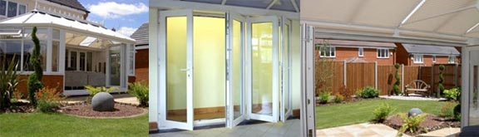
David Bingham, Managing Director at Conservatory Land stated that "Besides fitting a conservatory, they are one of the best ways of adding value to the home, as well as making the garden a much more accessible and enjoyable area for the whole family," and went on to say "In the last 12 months, bi-fold doors have become a must-have on many homes and we always recommend them to our customers who are fitting a conservatory."
Sliding bi-fold doors have the advantage of providing full access to the garden or patio area, which means that on a warm summer's day homeowners can literally open up their home to the sunshine, dramatically connecting the indoor and outdoor space. Bi-fold doors can replace an existing patio door in a house or form part of a new conservatory.
The bi-folds' amazing flexibility is seen in the various fold options, which make it easy to adjust the doors, depending on how much fresh air you require. Opening up to the largest 6.5 metres wide, bi-fold doors are certain to create a beautifully practical living space and ensuring circulation of healthy fresh air throughout your home.
Conservatory Land uses the market leading Eurocell profile system to make the sliding bi-fold doors because it has the reputation as one of the best quality systems on the market. Conservatory Land also sources from Eurocell because it is a local company, based in Derbyshire that offers a full range of windows, conservatories and doors. Offering a full range means being able to provide customers a perfect colour between the windows, conservatory and bi-fold, which is a great way to create a real "wow factor".
Homeowners that choose bi-fold doors from Conservatory Land have been immediately impressed by the practicality and stunning aesthetics of the product. Because every home is unique, bi-fold doors are available in a choice of sizes, colours and woodgrain finishes. This extensive range of styles means that bi-fold doors can be individually selected to complement both traditional and contemporary homes.
Exceeding the minimum requirement for construction, security, safety,
weather-tightness and strength, bi-fold doors are a great way for families to enjoy their garden and patio areas - the wide open space they create makes it easy to both hear and see children in the garden. When fitted into a new conservatory, it provides a truly stunning addition to any home.
Conservatory Land offers a wide range of high performance glass to ensure that your new bi-fold door, conservatory or windows provide you with an efficient and easy to heat home.
Customers wishing to view its bi-fold door range, along with a wide selection of conservatories, will find a welcoming atmosphere in its new showroom on Old Mill Lane Industrial Estate, in Mansfield, Nottinghamshire.
Contact Details: ConservatoryLand
Old Mill Park
Mansfield Woodhouse
Nottinghamshire
NG19 9BG
Tel: 01623 488 887

