Fort Lauderdale Cosmetic Dentist Dr. Charles Nottingham and the Extreme Makeover Dental Lab Film Dental Documentary
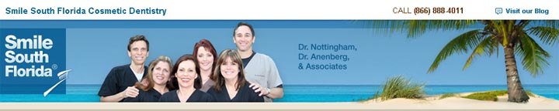
Released on: March 19, 2009, 6:56 am
Author: Fort Lauderdale Cosmetic Dentist
Industry: Healthcare
Smile South Florida® Cosmetic Dentistry is announcing that it will be joining forces with da Vinci Dental Studios (ABC's Extreme Makeover Dental Lab) to begin filming a dental documentary piece, which will be produced by the Emmy Award Winning Plum Television.
This documentary will air on Plum Television (Miami Beach Channel 5) in April 2009. The story behind the piece is to provide viewers with insight into the shared values and history of da Vinci Dental Studios and Smile South Florida Cosmetic Dentistry.
Da Vinci's founder, Daniel Materdomini, will be featured in the film, along with Smile South Florida Cosmetic Dentist, Dr. Charles Nottingham. Mr. Materdomini and Dr. Nottingham have been working together for over 20 years, taking cosmetic dentistry to a new level of excellence. Mr. Materdomini and da Vinci Dental Studios have showcased Dr. Nottingham's smile gallery cases in several predominant dental magazines. Dr. Nottingham even performed restorative work on Mr. Materdomini's mother.
In offering feedback on the work that South Florida Dentist Dr. Nottingham completed for his mother, Mr. Materdomini said that, "if the Extreme Makeover show was filmed in Florida, I am sure [Dr. Nottingham] would be the providing dentist."
During filming, Dr. Nottingham explained to Plum TV that many years before ABC's Extreme Makeover Show made da Vinci Dental Studios a household name for porcelain veneers, Dr. Nottingham had selected them as his dental lab of choice. With hundreds of dental labs in the local area to choose from, Dr. Nottingham decided to have his dental materials shipped across the country, in order to perfect his results. Dr. Nottingham went on to mention that da Vinci continues to share his commitment to quality and service.
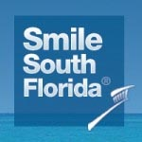
About Smile South Florida Cosmetic Dentistry The dentists at Smile South Florida Cosmetic Dentistry have offices in Broward County and West Palm Beach and serve patients from Boca Raton to Fort Lauderdale and Miami. The dentists specialize in dental aesthetics including porcelain veneers, dental implants, extreme makeovers, Invisalign, and sedation dentistry.

About Dr. Charles Nottingham Palm Beach Dentist & Fort Lauderdale Dentist, Charles Nottingham, D.D.S., Fellow in the Academy of General Dentistry, is an internationally and nationally renowned cosmetic dentist. He has been creating dazzling, healthy smiles for his patients since 1974.
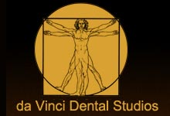
About da Vinci Dental Studios da Vinci Dental Studios, founded in 1976 by master ceramist Daniel Materdomini, who introduced the first porcelain veneer on the West Coast. Well-known for the da Vinci VeneerTM, which has been featured on numerous national and international television makeover shows, da Vinci Dental Studios is a full-service laboratory, manufacturing a wide-range of cosmetic and restorative products for dentists. Located in West Hills, California, da Vinci provides services for dentists throughout the United States, Canada, South America and Europe.
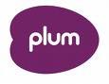
About Plum Television Plum operates television channels and websites in Nantucket, Martha's Vineyard, the Hamptons, Miami Beach, Sun Valley, Vail, Aspen and Telluride; destinations of choice for over 14 million of the nation's most interesting and influential people each year. They are Plum's audience as well as its content. Plum is available to a broader audience beyond its communities through video on demand and the Internet at plumtv.com
Contact Details: 7401 N. University Dr., Ste. 207
Tamarac, FL 33321
Tel: (954) 721-6950
Fax: (954) 726-4292

