More Parents Travelling For Child Surgery
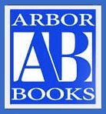

Released on: March 11, 2009, 12:30 am
Author: Arbor Books
Industry: Healthcare
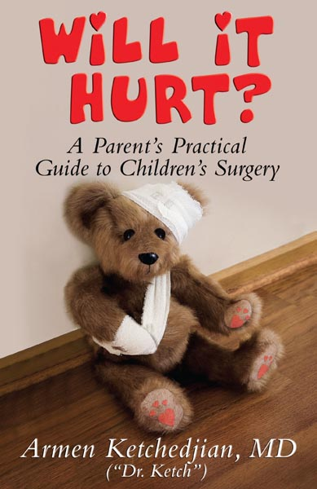
Traveling out of state or country for medical treatment, commonly referred to as medical tourism, is now catching on with parents seeking specialized surgeries for their children.
In the last few years, parents from around the world have flocked to the United States for specialized pediatric surgeries. And American parents have sought help in countries with nationalized healthcare or more affordable surgeries, such as India. But as with all surgical procedures and practices, experts are advising caution.
Dr. Armen Ketchedjian, author of the book Will It Hurt? A Parent’s Practical Guide to Children’s Surgery, says that any parent looking for the best care for their child should place quality first, and that any decision made about surgery should be done with the advice and counsel of the child’s pediatrician.
“Selecting a surgeon for a child can be a difficult process for parents,” says Dr. Ketch, as the author is known to his patients. “It’s a frightening thing to be told that your child needs surgery, and parents are sometimes slow to trust doctors to operate. So caution is a natural and advisable strategy.”
Hospitals like Beaumont Hospital in Royal Oak, Michigan, have adapted to the trend and deal with families from around the world—200 from Italy alone—who travel there to take advantage of the hospital’s specialized surgeries to restore vision in premature babies.
For American parents, the journey often leads them to areas with American-trained doctors working for lower wages. “Unfortunately, the healthcare companies sometimes insist on very strict criteria for approving a surgery,” says Dr. Ketch. “It has changed the way pediatric surgeons practice medicine.”
Dr. Ketch hopes that his book will contribute to better parent education about pediatric surgery in general and recommends that parents who are considering traveling to see specialists keep the following guidelines in mind:
* Look for a surgeon who has training in the kind of surgery your child needs
* Find out in advance what type of facility your child will have to be in for the procedure
* If you have a choice between a medical center that specializes in pediatrics and one that does not, choose the one that specializes in pediatrics
* Look for a surgeon who has extensive experience
These tips and more are part of Dr. Ketch’s efforts to give parents some insight into the world of pediatric surgery. He says hopes that more parents will take advantage of resources like his to learn about their options before making a final decision about where to take their child for surgery.
Will It Hurt? helps educate parents about pediatric surgery. It is an easy-to-read resource that will give parents, children and families the help and reassurance they need to make surgical experiences as stress-free as possible.
Listed in The Guide to America’s Top Anesthesiologists by the Consumer Research Council of America, Dr. Ketch trained at Cornell Medical Center, with a fellowship at Memorial Sloan-Kettering Cancer Center and a pain management elective at Boston Children’s Hospital. He has also worked to help develop new techniques in ambulatory anesthesia, taught medical students and residents, and cared for more than 10,000 patients.
Dr. Ketch is also the author of the children’s book Golden Apples (winner of the 2008 Reviewer’s Choice Award), a beautifully illustrated book that aims to help educate children about the dangers of drug abuse.
For more information, contact the author directly at support@dr.ketch.com.
WARREN ENTERPRISES, LLC and author Dr. Armen G. Ketchedjian chose Arbor Books, Inc. (www.ArborBooks.com) to design and promote Will It Hurt? A Parent’s Practical Guide to Children’s Surgery. Arbor Books is an internationally renowned, full-service book design, ghostwriting and marketing firm.
(Will It Hurt? A Parent’s Practical Guide to Children’s Surgery by Dr. Ketch; ISBN: 0-9815373-0-8; $14.95; 172 pages; 5½” x 8 ½”; softcover with illustrations; WARREN ENTERPRISES, LLC)
Contact Details: Arbor Books, Inc. (ABI)
244 Madison Avenue, #254
New York, NY 10016-2819
PH: 877-822-2500
www.arborbooks.com

