Mountainside Drug Rehab Provides Secluded and Quality Drug Addiction Treatment At An Affordable Price - Canaan, Connecticut (CT)


Released on: March 9, 2009, 6:49 am
Author: Mountainside Addiction Treatment Public Relations
Industry: Healthcare
Mountainside Drug Rehab Provides Secluded and Quality Drug Addiction Treatment At An Affordable Price - Canaan, Connecticut (CT)
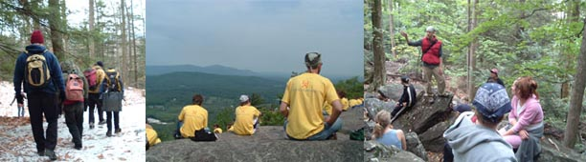
Nestled on 33 Acres at the base of a mountain in the foothills of the Berkshires, Mountainside Drug Rehab provides progressive therapies in an ideal setting for those seeking to recover from their drug addiction or alcoholism. What began 11 years ago as the thesis of accomplished professionals in the drug treatment field has developed into one of the most successful treatment centers - providing quality and effective treatment in an ideal environment for thousands of people.
Understanding the importance that an environment plays in a person’s addiction, the founders of Mountainside set off to find a natural, peaceful and rural setting for their center. Located at the base of their own mountain in Canaan Connecticut, complete with mountain streams, hiking trails to the summit and multiple waterfalls - Mountainside Drug Rehab offers its clients an opportunity to connect with nature and be immersed in the serenity that the beautiful surroundings provide.
Offering individualized treatment plans for every person that enters treatment, the Licensed and highly trained staff at Mountainside Drug Rehab provide compassionate and guiding care with a level of unparalleled dedication. Licensed to provide intermediate and long term inpatient treatment, Mountainside has a vast network of interventionists and aftercare centers across the globe that work diligently with Mountainside staff and clients to ensure a successful continuum of care. It is the progressive treatment methods and continuity of care that has attracted people from around the world to enter Mountainside Drug Rehab for their treatment needs.
This recent economic downturn has shown a renewed light on the services of Mountainside Drug Rehab. For more information on the acclaimed treatment program at Mountainside www.mountainside.org in CT or to schedule an admission, please call 800.762.5433.
Contact Details: Mountainside Drug Rehab www.mountainside.org
187 Route 7
Canaan, CT 06018

