Profits from My Kitchen - Two new online classes that help you earn and learn!
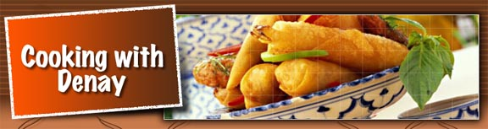
Released on: March 18, 2009, 5:22 am
Author: Detra Denay Davis
Industry: Food & Beverage
Cary, North Carolina –March 16, 2009 – Cooking with Denay has unveiled two new online classes for foodies nationwide. How to Operate a Home-Based Bakery is back by popular demand along with a new course, Cooking for a Crowd: Do It Yourself Catering. The classes are available online and designed to help bakers start a home-based bakery business; and help cooks learn the strategies and secrets behind cooking for large groups.
Everyone knows economic times are growing more unpredictable by the minute. Who isn’t looking for a way to earn or save money? How to Operate a Home-Based Bakery is for anyone who would like to operate a home-bakery business and sell their products directly to the public. Currently, there are 11 states that allow home-based bakers to sell their baked goods to the public; Iowa, Kentucky, Maine, New Hampshire, North Carolina, Ohio, Pennsylvania, Tennessee, Utah, Vermont and Virginia, along with numerous counties across the United States.
The second online course, Cooking for a Crowd - Do it yourself catering is designed to teach students how to cook for large groups. The micro course offers strategies, techniques and recipes for feeding the masses affordably; teaching students catering tips and approaches. Cooking for a crowd is not something done weekly or even monthly, but when a host needs to serve a large group, it must be done with style and finesse.
Instructor, Detra Denay Davis, is devoted to teaching everyone how to get back to the basics and fire up the oven! Currently a cooking instructor for the Wake County Public School Lifelong Learning Program, some of Denay’s former students have included personal chefs who wanted to impact their bottom line, a baker from Mexico selling her unique flavored tortillas and a mother of six who wanted to save a bundle catering the graduation party for twin daughters. Denay maintains online learning offers students flexibility, allowing them to work at their own pace, interact and learn from students all over the nation.
About the Instructor
Detra Denay Davis is a writer and cooking instructor living in Cary, North Carolina. She writes a Blog for everyday food enthusiast and a food column for iEmporium.com. A former caterer from Detroit, Michigan, Denay was featured in Bon Appétit magazine and is an active member of the International Culinary Professionals Association (ICPA), Slow Food (Triangle Chapter), and Southern Foodways Alliance, an organization dedicated to keeping the diverse food cultures of the American South alive. When Denay is not teaching she is the organizer of the Culinary Historians of North Carolina. Email Denay at: denay@cookingwithdenay.com
Contact Details: Detra Denay Davis
Cooking with Denay
P. O. Box 4935
Cary, North Carolina 27519
http://cookingwithdenay.com/
denay@cookingwithdenay.com
919-412-9158

