Sandbox Couture Announces the Addition of Laura Ashley Christening Gowns


Released on: March 16, 2009, 6:05 am
Author: SandboxCouture.com
Industry: Apparel & Fashion
Online children’s boutique is now carrying a fine selection of ceremonial gowns for the most important traditions
Rancho Santa Margarita, Calif., March 13, 2009 -- Sandbox Couture.com, a popular online children's boutique retailer of baby clothes, girls clothes and baby gifts, today announced the addition of Laura Ashley Christening Gowns, which complements its existing collection of special occasion garments. In addition to christening gowns, bris sets and first communion dresses, Sandbox Couture carries and a wide selection of trend-setting kids’ clothing.
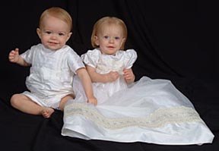
"A child’s life is full of milestones and memorable occasions, and finding just the right outfit or gown can be challenging," stated Sam Brown, spokesperson for Sandbox Couture. “At Sandbox Couture, we offer the finest infant christening gowns, first communion dresses and bris sets for these very important life events that later become commemorative keepsakes.”
The Laura Ashley christening gowns range from cotton gowns with embroidered lace gowns to comfortable cotton coveralls. The luxuriously soft Dupioni gown, family gown and silk rompers round out the elegant silk collection. The Dupioni silk gown features beaded lattice bodice, smocked waistband and a matching bonnet. The gabardine coverall features a pin-tucked one piece and the romper with vest make handsome choices for baby princes, while the eyelet gown and organza lattice gown add feminine detailing for precious little princesses.
Sandbox Couture chooses to provide exclusive, upscale christening brands for the discerning tastes of its customers. Little Things Mean A Lot fashions are the most beautiful, functional and high quality gowns for christenings and naming ceremonies available today. This collection also includes outfits for Jewish traditions such as Bris Sets and accessories. Hard to find preemie Christening Gowns, preemie christening sets and preemie outfits are also available.
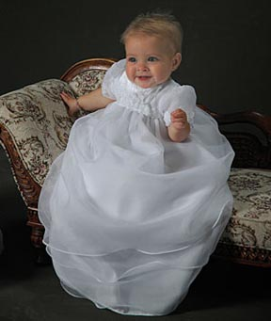
Known as the source for quality children’s clothes and couture fashions for babies and children, Sandbox Couture has provided busy parents -- and a loyal following of couture shoppers and celebrity moms -- a convenient outlet for quality, value and fashion savvy designs for little boys and little girls. Sandbox Couture has developed a reputation for offering couture children’s fashions, at prices that parents will appreciate. From unique designs to the hottest trends, Sandbox Couture's collection of designers offers the convenience of online shopping and the benefits of online savings.
About Sandbox Couture
Sandbox Couture is an online children's boutique retailer, providing baby clothes, baby gifts and unique children’s clothes. The company takes pride in hand selecting products from top designers, thereby ensuring quality and contemporary style. Sandbox Couture’s philanthropic contributions and socially conscious business practices are at the forefront of the company’s ideals and corporate culture. Founded in 2005, Sandbox Couture is privately held and headquartered in Rancho Santa Margarita, CA. For information about Sandbox Couture, please visit the company's web site at http://www.SandboxCouture.com.
###
Press Contact:
Sam Brown
949-459–2505
pr@sandboxcouture.com

