Sandbox Couture Introduces Quiksilver and Kate Mack Spring-into-Summer Fashions


Released on: March 26, 2009, 5:16 am
Author: SandboxCouture.com
Industry: Retail
Online children’s boutique is carrying the latest boys and girls fashions and swimwear by popular designers
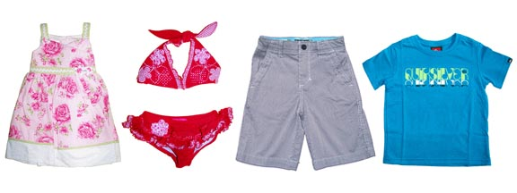
Rancho Santa Margarita, Calif., March 25, 2009 -- Sandbox Couture.com, a popular online children's boutique retailer of baby clothes, girls clothes and baby gifts, today introduced the addition of the 2009 season of boys clothes and swimwear by Quiksilver, along with fresh Easter, spring and summer dresses and bathing suits for little girls. These new styles for infants, toddlers and children will continue to arrive throughout the season.
"Southern California’s surf, snow and skate scene provides the inspiration for boys clothing and in this season’s Quiksilver styles, we see a mix of fun, attitude and good old fashioned comfort," stated Sam Brown, spokesperson for Sandbox Couture.
“For girls, the Kate Mack by Biscotti line of dresses and swimsuits ushers in the sunny, frolic-filled spring and summer days –just in time for Easter dress shopping or spring break. These styles are now available to customers around the world as we are shipping internationally.”
Inspired by the laid back Southern California surf scene, the Quiksilver boys collection features classic, retro and edgy designs on essentials such as board shorts, cargo pants, t-shirts, caps, beanies, backpacks, footwear and long-sleeved hoodies for bundling up on a brisk spring evening or after a day at the beach. Whether the look is beach casual or surf-skate punk, little tikes will be fashionably attired for outings, play dates or just kicking it at home.
Kate Mack for Biscotti features pretty spring dresses in pink and lime, pink leopard and rose halter or 2-piece bathing suit, rose dress with lime gingham accents, white polka-dotted flower dress and a variety of cute itsy-bitsy, teeny-weeny little girls’ bikinis and one-piece swim suits in the same family of fabrics and patterns. Matching sandals and flip flops round out this summer’s most sought after looks by Biscotti.
Known as the source for quality children’s clothes and couture fashions for babies and children, Sandbox Couture has provided busy parents -- and a loyal following of couture shoppers and celebrity moms -- a convenient outlet for quality, value and fashion savvy designs for little boys and little girls. Sandbox Couture has developed a reputation for offering couture children’s fashions, at prices that parents will appreciate. From unique designs to the hottest trends, Sandbox Couture's collection of designers offers the convenience of online shopping and the benefits of online savings.
Sandbox Couture is now serving the global community with its fashion forward trends and name brand selections. International shipping rates apply. For additional details, please visit www.sandboxcouture.com.
About Sandbox Couture
Sandbox Couture is an online children's boutique retailer, providing baby clothes, baby gifts and unique children’s clothes. The company takes pride in hand selecting products from top designers, thereby ensuring quality and contemporary style. Sandbox Couture’s philanthropic contributions and socially conscious business practices are at the forefront of the company’s ideals and corporate culture. Founded in 2005, Sandbox Couture is privately held and headquartered in Rancho Santa Margarita, CA. For information about Sandbox Couture, please visit the company's web site at http://www.SandboxCouture.com.
###
Contact Details:
Sam Brown
949-459–2505
pr@sandboxcouture.com

