Smile Gallery Sets South Florida Dentist Practice Apart From the Pack
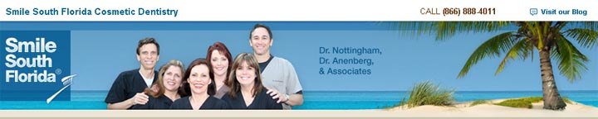
Released on: March 27, 2009, 9:12 am
Author: South Florida Dentist
Industry: Healthcare
"I have never seen a smile gallery as extensive as Smile South Florida’s and where the final result of every case is of such a high standard. "
Craig Galbraith daVinci Dental Studios ABC's Extreme Makeover Dental Lab
Want to see the results produced by the professionals at Smile South Florida Cosmetic Dentistry? The proof is on the walls.
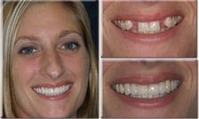
Nothing seems to show what a dental procedure can do for an individual like before-and-after photos.
With that in mind, Smile South Florida Cosmetic Dentistryin Fort Lauderdale created a Smile Gallery to show patients the great results that can be achieved throughcosmetic dentistry.
"It's one thing to tell patients what we can do for them," said Dr. Charles Nottingham, a cosmetic dentist who is the senior partner at Smile South Florida Cosmetic Dentistry. "It's another thing to show them."
Nestled within each elegant bronze frame that lines the newly renovated hallways, are two (8-inch x 10-inch) photos of patients' smiles- one before photograph displaying their dental procedure and one after.
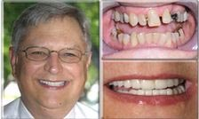
"The patients love it," said Office Manager Marianne Taylor. "This was the best thing to ever happen because patients see these photos and seem to feel encouraged that they are going to leave here with their desired results."
When Taylor discusses procedures such as laminates orporcelain veneers with patients, she can walk them through the hallway and point to a visual of how the completed procedures look.
Several types of procedures are featured in the Smile Gallery.
Congenital Malformation
It is not uncommon for people to be born without certain teeth. More than five percent of people lack upper second incisors or second premolars. One example of this in the Smile Gallery shows how a patient's missing anterior teeth were restored using two fixed porcelain Lava Bridges. The premolars were restored with porcelain veneers.
Overlapped, Crowded and Crooked Teeth
Teeth that are overlapped, crowded or crooked can cause oral health problems, such as periodontal disease, cavities and uneven wear. One example pictured in the Smile Gallery shows how a patient's smile was restored by placing porcelain crowns on the upper teeth to give the patient a straighter, wider smile than her original upper arch, which was too narrow and tilted inward.
Poorly Shaped Teeth
Photos in the Smile Gallery show how natural teeth that are oddly shaped and pointed in different directions can be improved with porcelain restorations.
Reverse Smile and Small Teeth
An imaginary line around the incisal edges of the upper front teeth should follow the superior border of the lower lip. This is called the "smile line." When the centrals appear shorter than the canines, this is referred to as the "reverse smile line." Smile Gallery photos show how this problem can be corrected by using porcelain veneers and crowns to create longer central teeth, a wider arch and improve the shape of the teeth.
Spaces, Stains and Failed Fillings
One dramatic Smile Gallery photo shows how proper fitting and anatomically correct porcelain crowns were used to close the spaces between teeth, decrease the flair of upper anterior teeth and re-contour the teeth.
"The Smile Gallery not only shows patients various types of dental improvements achieved through cosmetic dentistry, it gives patients confidence to follow through with suggested procedures", Taylor said.
Taylor recalled a recent patient who was so self-conscious about her teeth; she feared showing them to the dentist. Once Taylor walked the patient through the smile gallery and showed her the 'before' pictures of several other patients, the woman felt less self-conscious.
"This woman thought she was going to be the absolute worst case the doctors had ever seen," Taylor noted. "One trip through the Smile Gallery showed her this was not true."
About Smile South Florida Cosmetic Dentistry
The dentists at Smile South Florida Cosmetic Dentistry have offices in Broward County and West Palm Beach and serve patients from Boca Raton to Fort Lauderdale andMiami. The dentists specialize in dental aesthetics including porcelain veneers, dental implants, extreme makeovers, Invisalign, and sedation dentistry.
About Dr. Charles Nottingham
South Florida Dentist & Dentist in Florida, Charles Nottingham, D.D.S., Fellow in the Academy of General Dentistry, is an internationally and nationally renowned cosmetic dentist. He has been creating dazzling, healthy smiles for his patients since 1974.
Contact Details: Broward County Office
7401 N. University Dr., Ste. 207
Tamarac, FL 33321
Tel: (954) 721-6950
Fax: (954) 726-4292

