Tummy tuck and liposuction, before and after photos demonstrate why this combined surgery is becoming ever more popular


Released on: March 16, 2009, 6:15 am
Author: Beautiful Beings
Industry: Healthcare
Tummy tuck and liposuction, before and after photos demonstrate why this combined surgery is becoming ever more popular. At £2846, it has become more affordable for many men and women to have the combined procedure to their tummy region.
Tummy tuck surgery at an affordable price, provided by Beautiful Beings.
http://www.beautifulbeings.co.uk/
http://www.beautifulbeings.co.uk/cosmetic-surgery/procedures/tummy-tuck.htm
http://www.beautifulbeings.co.uk/cosmetic-surgery/procedures/liposuction.htm
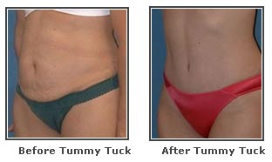
Abdominal cosmetic surgery, commonly known as a tummy tuck offers a solution by flattening the slack skin and tightening the muscles of the relaxed abdominal wall, which frequently occurs after pregnancy or a distinct weight loss.
If needed, excess subcutaneous fatty tissue can be removed as well. The appearance and functional results of the tummy tuck are substantial, although scars are inevitable in order to remove excessive skin from the tummy during a tummy tuck. It leaves a permanent scar after. However, it will fade after time and its quality differs per individual. A tummy tuck is not only an aesthetic cosmetic surgery procedure but it provides a solution to functional deficiencies of the abdominal wall, i.e. inferior rectus muscle diastases. A tummy tuck not only brings about a better appearance and function, but it also stops the slackening process of the abdominal wall.
Contact Details: beautiful beings
10 birch road, onehouse
stowmarekt, suffolk ip14 3ez united kingdom

