Web Design and SEO Go Hand In Hand To Achieve Results In Search Engines


Released on: March 10, 2009, 8:04 am
Author: Creare Design
Industry: Marketing
Some businesses think they can attract customers to their business simply by having a wonderful, clean-cut, web design. Unfortunately they are mistaken. The chances of word of mouth spreading the news of their brand spanking new website, that has gadgets and gizmos galore, simply (and sadly) won’t have any impact that these companies may hope to achieve.
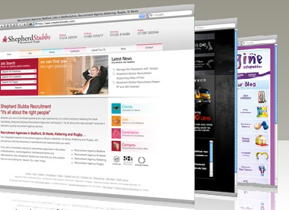
Fortunately for companies struggling to have their web site founded by potential customers in the search engines, The Creare Group can offer the solution by giving customers an opportunity to have both a unique web design, as well as providing them with the service of Search Engine Optimisation.
The Creare Group integrate both web design and SEO to provide a full service to maintain good customer relations so all consultants and designers know the customer from a professional level. This all goes towards creating good relations with the customers to understand the results they hope to achieve from their web site.
‘ Our aim is to not just create professional and user friendly web sites, but to maximise it’s potential so it becomes in the top rankings of all the major search engines. We believe there is little to gain from having a web site if it doesn’t fulfill it’s purpose; creating interest in a product or service.’ Mike McKinley MD The Creare Group.
The Creare Group’s main theme is merging both web design and search engine optimisation to maximise the potential that a web site holds to making a business successful. With constant SEO tools being found and upgrading the way they market their customers sites, The Creare Group is one of the best when it comes to understanding how a web site succeeds.
Recently The Creare Group has opened up the opportunity to provide their customers with a video file with information about the customer’s service being expressed by a representative. Simple yet effective tools are always being found by the consultants of The Creare Group to push their customer’s sites further up the rankings, making them as successful as they have been.
Contact Details: 15a High Street, 01455 55 00 62, colin@creare.co.uk,http://www.crearedesign.co.uk

