4th Annual Parental Alienation Awareness Day continues to Shed Light into the darkness of Parental Alienation


Released on: April 24, 2009, 5:46 am
Author: Parental Alienation Awareness Organization
Industry: Healthcare
TORONTO, April 23, 2009 – Nearly everyone knows a couple who has divorced and used a child against the other parent. But not many people know there’s a name for such behavior--and fewer still know it is a particularly damaging form of child abuse.
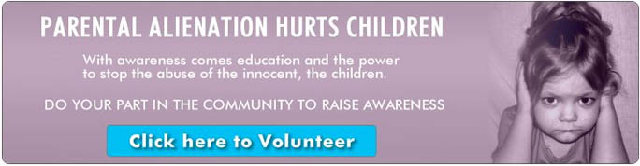
The 4th Annual Parental Alienation Awareness Day on April 25, 2009 is set as a day for families around the Globe to help raise awareness about this rampant global issue. Many countries, states, provinces, and cities have already proclaimed April 25 to be Parental Alienation Awareness Day, and many educational and family events are set to take place in cities in North America, Europe, South America, Australia, and New Zealand. .
Parental Alienation is defined as a set of behaviors exhibited by a parent or an adult the child trusts, that puts the child in a very damaging loyalty bind between the people they love. These behaviors can be as mild as the occasional badmouthing of a parent, but in extreme cases may lead to parental Abductions and even Parental Homicide.
Research shows that children exposed to Parental Alienation may suffer a lifetime of low self esteem, and depression as well as substance abuse, anxiety, and difficulty trusting anyone or forming lasting relationships.
“A pattern of alienation usually begins without any malicious or conscious intent to harm the relationship between the other parent and the children,” explained Sarvy Emo, Founder of Parental Alienation Awareness Day. “Parents are often unaware of how subtle behaviors and comments can put children in a loyalty bind that is not only harmful to their emotional and mental health, but may affect their relationship with the targeted parent.”
“… the hurt, the anger, the shame and the pain would never go away. I could numb it and put it in the back of my mind but it never went away. It comes out in how I am as a mother, a spouse, a friend. In the decisions I’ve made, in almost everything I do.” Says an adult who experienced Parental Alienation as a child.
Parental Alienation Awareness Organization urges family members, and the people that surround a child’s life to watch for the children perceiving one parent as causing the other parent’s financial problems, showing a sudden negative change in attitude around one parent or being uncharacteristically belligerent around a parent or other authority figure.
To learn more about PA and Parental Alienation Awareness Day, visit
http://www.paawarenessday.com.
To learn more about Parental Alienation and Hostile Aggressive Parenting, visitwww.paawareness.org
Contact Details: Parental Alienation Awareness Organization
Tel: 416-840-5654
info@paawareness.org
www.paawareness.org

