Affordable and Successful Drug Rehab and Alcoholism Treatment Center
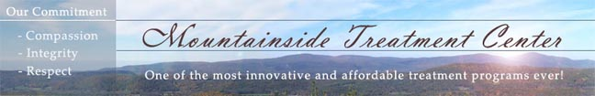

Released on: April 10, 2009, 2:18 am
Author: Mountainside Substance Abuse Treatment Center
Industry: Healthcare
Mountainside Treatment Center has been successfully treating adults who suffer from drug and alcohol addiction with better than average results for 11 years now. We are a non-profit alcohol and drug addiction treatment center. Our licensed and certified professional staff is trained in wide areas of counseling including a Nurse Practitioner.
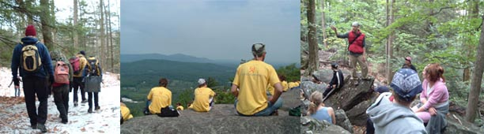
We offer Individual, Group, Gender Specific and Family Counseling as well as a full Mind Body Wellness Program consisting of Yoga, Guided Meditation for relaxation, and Tai Chi. We also offer 12 Step Meetings and Education, Nicotine Recovery, and a full Adventure Based Initiatives Program complete with a Low Ropes Course under the guidance of our Adventure Based Counselors. Visit our website to learn more. http://www.mountainside.org/drug-rehab
Contact Details: Mountainside Treatment Center
187 South Canaan Rd.
Canaan, CT 06018
800-762-5433
http://www.mountainside.org/drug-rehab

