Catch Us If You Can –Young Entrepreneurs Build Business and Following


Released on: April 20, 2009, 2:24 am
Author: Nextvoice247
Industry: Internet & Online
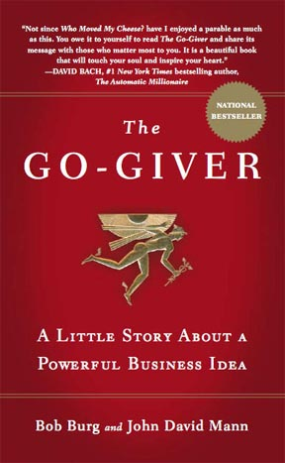
What happens when you give video cameras, a world changing book, and a 1200-mile road trip to four out of the box entrepreneurs? They don't know what it looks like either but with all of these forces aligning, it will be one monumental adventure. Through the power of Social Media, four visionary entrepreneurs have been connected to Bob Burg, the co-author of their favorite book, The Go-Giver. The Go-Giver, the internationally best-selling book co-authored by John David Mann is finding a new audience. These four entrepreneurs represent only a fraction of the millions of people already positively influenced with the message and principals in this book and its principles.
What started out a simple van ride has turned into a national tour – The Go-Giver Tour (http://www.gogivertour.com). The tour now has national supporters and stops in St. Louis, Nashville, Atlanta from April 22-23, 2009. They will meet followers of the book, the entrepreneurs and momentum built through sites like Twitter and Facebook. Finally landing in Orlando at the Extreme Business Makeovers Conference April 24-26, 2009.
The four have extended their efforts to support emerging leaders and young entrepreneurs by holding a video-based interview contest and are bringing five diverse individuals along for the ride. These young entrepreneurs represent cultural diversity and diverse business experience in varying development stages. The goal is to create winning plans to help build brand and business skills, develop authentic leadership skills and learn the true principle of adding value for themselves, their stakeholders, and their customer.
Supported by the Nextvoice247 Initiative (www.nextvoice247.com) Founder, Gilbert Melott states, “This started out as a connection between a social media rock star and an author. It has ended up connecting untold numbers of people around a single belief. It will be great to see these young entrepreneurs be supported by the 100,000’s of people who will come to get to know their stories.”
Contact Details: Gilbert Melott
831 W Buckingham #3
Chicago, Il 60657
info@nextvoice247.com
www.nextvoic247.com
www.gogivertour.com

