Cherry Launches Ultra-Compact Dust-Proof Keyboard


Released on: April 6, 2009, 8:22 am
Author: Cherry Electrical Products, Inc.
Industry: Computers
Pleasant Prairie, WI - Cherry’s new G86-52400 industrial keyboard offers IP54 dust-proof and water-resistant rating and an overall package length of just 11.8".
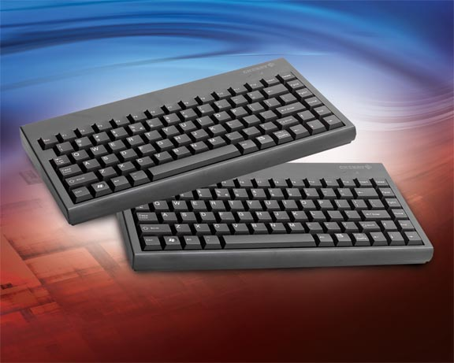
Whereas competitive products typically offer keystroke endurance of 5 million operations, the G86-52400 is rated to 25 million operations, ensuring industrial users high reliability and reduced maintenance concerns.
Overall dimensions of the 83-key G86-52400 are 11.8" x 6.3" x 1". The small footprint of the G86-52400 makes it ideal for space-constrained applications in rack-mount servers, in-vehicle computing and medical diagnostic equipment.
The keyboard offers USB 2.0 interface and comes with a 2-year warranty. The keycap legends are created by laser, so foreign language versions can be created in a simple customization process.
For further information on the new G86-52400 series keyboards, contact a Cherry keyboards specialist at ZF Electronics Corporation, 11200 88th Avenue, Pleasant Prairie, WI 53158. Telephone: 800-510-1689. Email: sales@cherrycorp.com. Website:http://www.cherrycorp.com
About Cherry
Cherry, a brand of ZF Electronics Corporation, provides computer keyboards, standard and custom electrical switches, sensors and controls for the worldwide automotive, computer and consumer/commercial OEM markets. ZF Electronics has offices and factories in Germany, England, France, Australia, Czech Republic, Mexico, Hong Kong and the United States.
Contact Details:
Steve Hugener
Cherry Electrical Products, Inc.
262-942-6679

