Click Consulting Launches CIO Assessment Program


Released on: April 8, 2009, 3:29 am
Author: Click Consulting
Industry: Computers
New program recasts the role of technology in SMBs to become a key driver of business growth
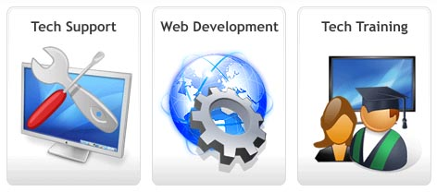
Irvine, Calif., April 8, 2009 -- Click Consulting has created a new service helping small businesses understand the way that technology fits inside of their business, the CIO Assessment. After looking at the way technology was treated inside of their own client’s businesses, Click Consulting decided that they had to develop a system of connecting business goals and IT so that technology was no longer overhead but rather a driver of business.
“In today’s climate of tighter spending and shrinking margins, IT can become a true driver of business growth if the appropriate technologies are in place,” said Jeff Lenning, president, Click Consulting. “Our CIO Assessment program helps companies analyze their current situations and makes recommendations based on each company’s unique requirements. We keep up with the latest technologies so that our clients can focus on running their businesses.”
Most small businesses spend their time thinking about their business, not the technology that runs it. At the same time, most managed services companies just maintain the IT infrastructure without thinking about the business it exists within. Few IT service firms ever work with small businesses from a business perspective; instead everything becomes a maintenance issue so growth never occurs as a result of IT spending. Click Consulting decided that this downward spiral needed to stop.
The CIO Assessment process starts with in-depth interviews of major stakeholders and decision makers at the company to understand the business choices that are being made. Then, after a deep inspection of the technology currently used at the company, Click Consulting delivers a report complete with suggestions about how to better align technology and the business. The assessment becomes a roadmap, helping guide the growth and profits of the company over time.
About Click Consulting
Click Consulting is a full service IT and Web Development company based in Irvine, Calif. Focusing on small and growing companies, Click provides remote IT support, on-site tech support, self-managed websites, and fully custom web projects. Trusted by industry leading companies to manage their business critical networks and applications, Click Consulting specializes in Tech Support, Web Development and Computer Consulting. For more information, please visit http://www.clickconsulting.com/technicalsupport/cio-assessment.
# # #
Contact Details: Cody Boyte
Click Consulting
18013 Skypark Circle, Suite C
Irvine, CA 92614
(949) 468-3814
www.clickconsulting.com

