Criswell Nissan moves to a state of the art facility in Germantown, Maryland. Criswell Nissan sells to customers in Maryland, Washington, DC and Northern Virginia. www.criswellnissan.com


Released on: April 7, 2009, 2:14 am
Author: Criswell auto
Industry: Automotive
Germantown, Maryland 4-7-09: Criswell Automotive announces that Criswell Nissan has moved from Gaithersburg to Germantown, Maryland. Only 3.5 miles away from the old location, the new state of the art facility is worlds above in customer amenities and service facilities.
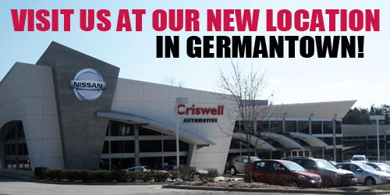
Located next to Criswell Honda on Amaranth Drive, Criswell has built a unique Import Sales destination in Montgomery County.
To celebrate the dealership’s arrival in Germantown, Criswell Nissan is having a inventory reduction sale for the entire month of April. The new facility is busting at the seams already, with one of the largest selections of new Nissans in stock, some with 0% financing on approved credit.
Criswell Nissan has discounted prices and applied rebates up to $6,000 on select models. There are even a few 2008 models left at never before offered prices. Criswell Nissan invites all customers in Maryland, Washington, DC and Northern Virginia to come see their new showroom and take advantage of great deals.
Criswell Nissan is part of the Criswell Automotive family selling and servicing Nissan, Honda, Chevrolet, Hummer, Lotus, Commercial and Isuzu trucks. Visitwww.criswellauto.com to get a great deal on a new or used car.
Criswell Nissan
19525 Amaranth Drive
Germantown, MD
Contact Details: Criswell Nissan
19525 Amaranth Drive
Germantown, MD
gbarmby@criswellauto.com
240-364-7115

