DeBurring on Same Machining Center Horizontal (HMC) & Vertical (VMC) in Few Seconds with Flow Through Holders & Brushes

Released on: April 1, 2009, 9:33 am
Author: Praveen Panchal of IMEXSU
Industry: Industrial
Mumbai, Maharashtra, India April 1, 2009 -- A newly developed DeBurring system on a user's same machining center to withstand against the present scenario and market situation; IMEXSU can try to help a little bit to survive in this tough situation by:
* Cutting cost per components
* Improving quality
* Reducing delivery time.
* Reducing manpower
* Giving consistency
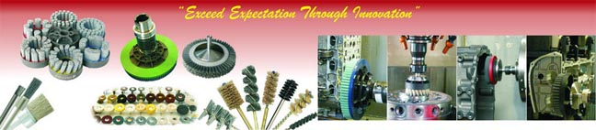
In this time of financial crisis, DeBurring Brushes & Holders brings cost-effective and appropriate solutions for DeBurring, Micro DeBurring, Surface Preparation and Radiusing needs on same Machining Center like VMC / HMC machines on both metal and non-metal.
Presently, DeBurring Brushes & Holders is more focused on catering solutions to every DeBurring problem faced during machining. In today's very fast, most modern and intelligent machines, productivity has increased in multiplications beyond limits, as a result free availability of Burr on most operations.
To overcome this problem in the shortest possible time is the need of the hour, as time is money.
It is the right time to think of introducing a few new things to a present Machining system, which will save a lot of time and hard-earned money; it's time to contact a DeBurring Solution provider, IMEXSU, which has been one since 1976.
The range of MID (Machine in-line DeBurring) is unique, and that's tomorrow's need, but IMEXSU is ready to offer today. This is just few form wide range.
IMEXSU offers standard holders to be fitted directly to present holders like BT, ISO, HSK and others, with shank sizes Diameter 12, 16, 20, 25, 32 & 40mm with or without side-lock to be directly fitted to holder with help of Collete, Hydro-grip, Shrink-fit, Side-locks. With water flow through.http://www.de-burring.com
[DeBurring Directly on Machining Center]
The brushes are available from Diameter 50, 60, 80, 100, 125, 160, 165, 180, 200, 225, 250 & 296 and many more.
Brushes from Dia. 100 and above are also available in water flow through.
Grit available from 46 to 1000 more, and types are Diamond, Ceramic, Silicon, Aluminum, etc.
IMEXSU has more then 76 types of DeBurring products to suit every individual's needs.
Contact Details: IMEXSU (INDIA)
( GPS position N 19°07.136’ ; E 072°53.316' )
8-A, Vaibhav Industrial Estate, Baji Pasalkar Marg, Next to SakiVihar Telephone Exchange,
Mumbai - 400072, INDIA
Telephone +91-22-28570339 / 0445 / 2814, Fax +91-22-28574829
USA Fax. +1-413-771-3099, UK Fax. +44-870-169-4236
Email:- pm1@imexsu.in, Website:- www.imexsu.com &
www.de-burring.com

