Free E-book Reveals Internet Money Making Strategies


Released on: April 13, 2009, 2:10 am
Author: Dotcomology
Industry: Internet & Online
These days everyone is looking for ways to make extra money. Maybe you’ve been laid off. Maybe you took a pay cut to keep your job. Maybe you’re just tired of working for someone else and having very little to show for it.
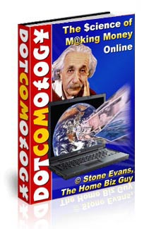
It is no secret that the hottest opportunities for generating income these days is to get involved in an internet business. In fact, searching on “internet income opportunities” will bring up 46,600,000 results on any given day on Yahoo.
There is absolutely no question that there is money to be made using the internet. In fact, there are multiple ways to generate internet income. The question is, which methodology works the best and how much do you have to spend before experiencing a return on your investment?
There is no shortage of experts that are willing to sell you their profound secrets on how to make money, online or off. Sometimes it can be difficult to distinguish the true experts from the novices impersonating the experts. Whether they want twenty dollars or two hundred dollars, you are probably skeptical that you are going to get value for what you pay for.
One solution to deciding on how to spend your money, is to not spend any money at all. There is a multitude of free resources that can provide you with information on how to work at home online. However, money is not the only component of your investment. Your time can be extremely valuable as well. Not all free info products are created equal.
I recommend that if you are interested in a home business opportunity working on the internet, you take some time to read the free ebook “Dotcomology.” You can download this book here:
http://www.MLMToolsForYou.com/pluginbonus.html
Here is an example of some of the valuable information included in this book:
- How to publish your own best-selling book even if you hate writing
- How to create hot software products even if you have no programming experience
- How to use press releases to gain an avalanche of free publicity for your business
- Viral marketing secrets to catapult your sales and multiply your online profits
- Battle-tested secrets to balance your business and family life

Don’t spend a dime on any other internet marketing material until you have read this book. Then, visit the full web site to get more information on how you can claim your share of the internet market today. Check it out here: http://www.mlmtoolsforyou.com

