Free Resources Offered by Mesothelioma-Data.com Help Victims Learn More about Asbestos-Related Diseases


Released on: April 23, 2009, 4:15 am
Author: Mesothelioma-Data.com
Industry: Healthcare
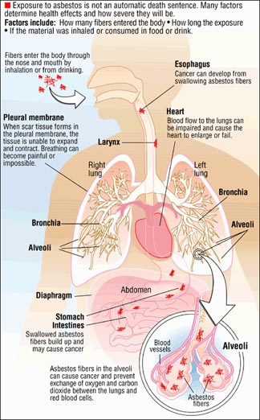
Houston, Texas, April, 2009 -- Mesothelioma-Data.com gives visitors access to free data and information on mesothelioma, symptoms of the disease, and treatment options. Although access to the site's complete resources is available online at no cost, visitors can also sign up to receive a free information packet and DVD containing the full data and statistics in one convenient package.
Mesothelioma-Data.com is one of the most comprehensive sources of mesothelioma information on the Internet. The site allows individuals to browse recent news items on mesothelioma, learn about the effects of asbestos on human health, peruse statistics on the disease, explore useful mesothelioma links, and make use of helpful resources pertaining to clinical trials, compensation, and veterans issues.
Mesothelioma is a rare form of cancer, which is caused by exposure to asbestos. Approximately 2,000 to 3,000 new cases of the disease are diagnosed each year in the United States.
Between 1970 and 1990, the incidence of mesothelioma cancers increased. Asbestos-related diseases stabilized after the 1990s, and now appear to be decreasing. In Europe and the rest of the world, mesothelioma rates are on the rise.
Mesothelioma is a serious disease that is difficult to treat. By the time a patient experiences symptoms and receives a diagnosis, the disease is usually already in advanced stages. However, advances in technology have helped improve prospects for patients that have been recently diagnosed.
Most cases of mesothelioma affect men aged 55 and over, and its incidence increases with age. 75% of people diagnosed with mesothelioma are over the age of 65. The disease affects men 5 times more often than women, and is most common in white Americans.
Mesothelioma affects the mesothelial cells that surround the lungs, heart, and stomach. Symptoms of the disease include dyspnea and pleuritic chest pain, malaise, and weight loss.
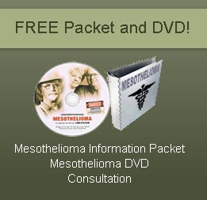
Mesothelioma is a difficult disease to treat. In most cases surgery is not possible because the tumor encases the lung in a large mass that invades the fissures and spreads to the diaphragm and chest wall. Chemotherapy and radiation have only proven helpful in rare cases. Fortunately, many patients have recovered because of new treatment options and earlier diagnosis.
For more information about mesothelioma, call 1-800-780-2686 or visit http://www.Mesothelioma-Data.com.
About Mesothelioma-Data.com: Mesothelioma-Data.com provides free resources and information to patients suffering with mesothelioma. The website has developed a free information packet and DVD that make it easy to become informed about the disease of mesothelioma, its symptoms, and treatment options.
Contact Details: Danziger & de Llano L.L.P.
440 Louisiana #1212
Houston, Texas 77002
Toll free: 1-800-362-1479
Fax: 713-222-8866
http://www.Mesothelioma-Data.com

