Glamour39.com Unveils Their Jewellery Collection
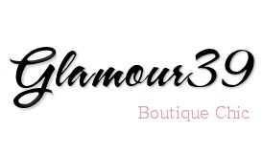
Released on: April 21, 2009, 4:20 am
Author: Diane Calliste
Industry: Retail
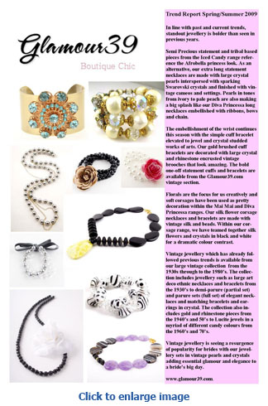
Woman love jewellery and so do we at Glamour39.com! Glamour39.com has brought together six beautiful key jewellery collections ranging from the flower influenced Mai Mai Collection to the Glamour Vintage collection.
Glamour39.com is an online jewellery consortium that showcases all six of our jewellery collections. Each collection comes under the Mai Mai Jewels company and for the first time all of our jewellery collections can be found in one space. In line with past and current trends, standout jewellery is bolder than seen in previous years.
Statement necklaces and bracelets from our Iced Candy collection are studded with large semi precious stones such as amethyst, agate, natural crystal and green and lemon jade. Tribal based pieces from the Iced Candy range reference the Afrobella princess look. As an alternative, our extra long statement necklaces are made with large crystal pearls interspersed with sparking Swarovski crystals and finished with vintage cameos and settings. These are available from our Diva Princessa range. Pearls in tones from ivory to pale peach are also making a big splash like our Diva Princessa long necklaces embellished with ribbons, bows and chain.
The embellishment of the wrist continues this season with the simple cuff bracelet elevated to jewel and crystal studded works of arts. Our gold brushed cuff bracelets are decorated with large crystal and rhinestone encrusted vintage brooches that look amazing. The bold one-off statement cuffs and bracelets are available from the Glamour39.com vintage section.
Florals are the focus for us creatively and soft corsages have been used as pretty decoration within the Mai Mai and Diva Princessa ranges. Our silk flower corsage necklaces and bracelets are made with vintage silk and beads. Within our corsage range, we have teamed together silk flowers and crystals in black and white for a dramatic colour contrast. The Mai Mai range incorporates semi precious hand carved flowers and stones detailing the natural influences currently seen on the catwalks. Big chunky natural beads from the Mai Mai range have been used to create double wrap bracelets in Lapis, tiger’s eye, denim sodalite and Jade.
Pendant jewellery is just as popular and our large pendants made from faceted cut semi precious stones are available from our Gems Bijoux and Iced Candy collections.
Vintage jewellery which has already followed previous trends is available from our large vintage collection from the 1930s through to the 1980’s. The collection includes jewellery such as large art deco ethnic necklaces and bracelets from the 1930’s to demi-parure (partial set) and parure sets (full set) of elegant necklaces and matching bracelets and earrings in crystal. The collection includes designer vintage pieces from Juliana, Nina Ricci and Listner. The collection also includes gold and rhinestone pieces from the 1940’s and 50’s to Lucite jewels in a myriad of different candy colours from the 1960’s and 70’s. Vintage jewellery is seeing a resurgence of popularity for brides with our jewellery sets in vintage pearls and crystals adding essential glamour and elegance to a bride’s big day.
For 2009/2010 it’s the unconventional and eye-catching pieces of jewellery that will make you and your outfit stand out from the crowd.
The jewellery collections are available from www.glamour39.com.
Contact Details: Mai Mai Jewels and Accessories Ltd
483 Green Lanes
London
N13 4BS
diane@maimaijewels.com
www.glamour39.com or www.maimaijewels.com

