Introducing Belden's New Flexible Keyconnect Workstation Outlet System For High-Performance, Easy-To-Install Work Area Outlets

Released on: April 21, 2009, 3:38 am
Author: Belden
Industry: Computers
RICHMOND, IN - Belden (NYSE: BDC), a world leader in the development of signal transmission products for enterprise, industrial, building management, broadcast and security applications, has introduced a new KeyConnect Workstation Outlet System that provides high density, flexibility and ruggedness for high-performance copper, fiber and multimedia applications at the work area outlet.
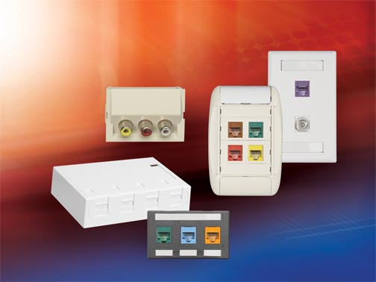
Benoit Chevarie, Product Line Manager of Belden's Copper Connectivity products, states: "The KeyConnect Workstation Outlet System uses a modular approach that provides versatility across several applications, uniform aesthetics and reduced inventory while maintaining Belden's reputation for reliable signal transmission performance, durability and manageability."
The KeyConnect System is comprised of KeyConnect Faceplates, Adapters, Boxes and Modules. Each modular component of the Belden KeyConnect Workstation Outlet System seamlessly fits together to suit any data, voice, video or multimedia application, including all levels of data networking, CCTV and high-definition video, fiber-to-the-desk and audio-visual applications. The various styles of KeyConnect Adapters and Boxes also support modular furniture and surface mount applications.
The new KeyConnect System features a wide range of UTP, coax, fiber and audio-visual modules with a smaller footprint for high-density use in patch panels and outlets. The modules snap effortlessly into Belden KeyConnect and MediaFlex® faceplates, adapters and boxes at the workstation outlet and into KeyConnect and AngleFlex™ Patch Panels in the Data Center. They are easily inserted and removed from any keystone-style opening providing design flexibility.
Available in a variety of colors and styles to fit any office décor, the KeyConnect System enhances manageability and identification with built-in top and bottom labeling windows on Faceplates and more than 11 colors of KeyConnect Modular jacks for color-coding outlet connections based on application.
For more information about the KeyConnect Workstation Outlet System, download NP 302 at http://www.belden.com, or contact Belden, P.O. Box 1980, Richmond, Indiana 47375, 1.800.BELDEN.1. FAX: 765.983.5294.
About Belden
Belden is a customer focused company. We ensure that our customers' communications infrastructure issues are resolved and that they benefit from the best signal transmission performance for their investment. We deliver leading-edge copper and fiber cabling/connectivity systems, wireless technologies, and active switch devices. We employ customer-centric go-to-market strategies and we implement and retain world class manufacturing processes. Our partners span the globe, helping our customers design, install, operate and maintain their communications applications. And our experience is vast, including expertise in Enterprise, Industrial, Infrastructure, Transportation, Professional and Enterprise Audio and Video, and Government applications. To obtain additional information contact Investor Relations at 314-854-8054, or visit our website at http://www.belden.com.

