Lanner to Release 16-Channel All-in-One H.264 Video Encoding Mainboard at Secutech


Released on: April 16, 2009, 2:37 am
Author: Lanner Electronics Inc.
Industry: Electronics
Lanner Electronics, Inc., a leading designer and ODM manufacturer of advanced network video hardware, today announced its participation at the 2009 Secutech Expo, during which it will unveil a new 16-channel all-in-one H.264 encoding video mainboard for digital surveillance and other IP video applications.


The Lanner VM-P016 video encoding mainboard enables network video solution providers to develop applications using a single mainboard for up to 16 channels of H.264 encoded IP video. The VM-P016 mainboard provides 16-channel BNC inputs to enable the creation of hybrid analog/digital video surveillance systems, receiving and converting analog video signal to H.264 encoded digital video at up to Full D1 resolution and 30 frames per second (NTSC) or 25 fps (PAL).
The Secutech Expo is Asia’s premiere exhibition for the surveillance industry, and Lanner will be presenting a range of advanced H.264 network video platforms at the show. Among the highlights of the Lanner exhibit, the VM-P016 combines all of the audio and video inputs required to build a complete network video server with a single mainboard, without the need to add additional video or audio capture cards or H.264 compression hardware.
The VM-P016 includes a Socket LGA775 supporting dual and quad-core Intel Core and Core 2 processors, up to 4GB DDR2 RAM in two DIMM sockets, six SATA II ports, four USB 2.0 ports, a single serial port and dual GbE LAN. Significantly, the VM-P016 supports 16 channel video looping and provides a BNC sequence monitor output for viewing multiple video streams sequentially in real time. RCA TV-Out and S-Video are also included, along with a standard VGA out port. Operating system support includes Windows XP, Ubuntu and Fedora Linux.
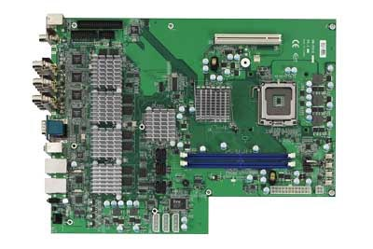
The Lanner VM-P016 comes with Lanner’s EyeShot 2000 NVR Control Panel reference software and SDK, which includes RAW data preview, AV encoding, streaming, software decoding, and display functions for alarm I/O, and supports motion detection, video loss detection, night detection, PTZ and alarm functions.
Aside from network video surveillance, target applications include broadcasting, digital signage, Video on Demand, medical video analytics and other video over IP applications.
Lanner will be exhibiting at booth #N905-N908 at Secutech 2009, which runs from April 22-24 at the Taipei World Trade Center Nangang Exhibition Hall. For more information, contact a Lanner representative via email at email sales@lannerinc.com , or visit us on the web at http://www.lannerinc.com.
Contact Details: Erin Su
Lanner Electronics Inc.
Taipei, Taiwan
www.lannerinc.com
sales@lannerinc.com

