Laughingbird Software Announces the #1 Best Selling Logo Design Software

Released on: April 23, 2009, 4:06 am
Author: Laughingbirdsoftware.com
Industry: Computers
City, State, April, 2009 -- Laughingbird Software (www.laughingbirdsoftware.com) has announced that their popular logo maker, "The Logo Creator," that in past has been rated the #1 best selling logo creator software in the retail sector by NPD Techworld, is one of the Top Selling Products on the internet for Laughingbird software today.
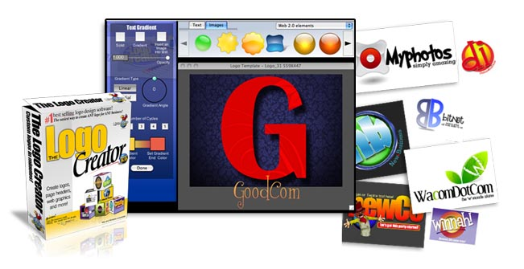
The Logo Creator makes it easy for small business owners and individuals to design high quality logos for a variety of different purposes. The Logo Maker Software comes with a large selection of eye catching logo templates that simplify the process of creating a memorable logo for your website, business, social network group, or blog. Compatible with Mac and Windows, The Logo Creator is the perfect solution for affordable web design.
The Logo Creator has enjoyed success since it first came onto the market in July, 2000. The first version of the software, Logo Creator v1.2, was the first and only logo design software made available to the everyday consumer. A newer version of the creator (v.3.0) was introduced in July, 2003. The updated software included a more flexible design interface, easier manipulation of logo elements, and access to online software updates.
The latest version of The Logo Creator has more than 50 customizable logo templates in each set. There are 9 logo packages available in total, including the Web 2.0 Logo Edition, the Corporate Logo Edition, and the Entertainment Logo Edition.
The software can save time and money, which is perfect for small businesses logo maker that wants to create a unique image for their company quickly and easily. No graphic design experience is required to use The Logo Creator.
A number of competitors have arrived on the scene since The Logo Creator was first created almost 9 years ago. But with all the innovations included in the Logo Creation Suite 5.0, buyers are given access to the best tools for developing a professional-looking logo that can take their businesses to the next level.
You can also use The Logo Creator for e-mail signatures, web page graphic design, presentation slides, newsletter pages and anything else that needs high quality graphics.
For more information about The Logo Creator, contact Laughingbird Software or visithttp://www.thelogocreator.com.
About Laughingbird Software: Laughingbird Software has been operating since 1998. Since its first launch, The Logo Creator Software has become the company's most popular product, winning praise from consumers and industry professionals alike. Laughingbird Software creates software products for small business owners that make it easy for the designated logo maker to achieve professional results for an affordable price just like their Corporate Logo Creator for larger businesses.
Contact Details: Marc
Laughingbird Software
http://www.thelogocreator.com

