Local Bands should check out Wix.com web design platform


Released on: April 1, 2009, 9:55 am
Author: Wix.com
Industry: Internet & Online
How are up-and-coming bands marketing themselves more effectively than signed artists--and putting the final nail in the record company coffin in the process?
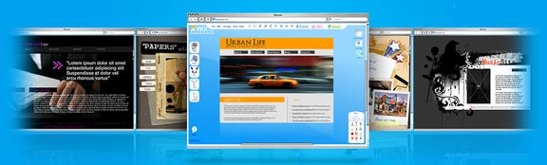
The answer: new online web design platforms like Wix.com that let non-tech savvy musicians create dynamic flash website and MySpace pages (for free) that not only rival, but exceed the quality of professionally made websites.
As I’m sure you know, record companies have been taking it on the chin the past few years with music sales drying up. But their saving grace has been their powerful marketing arms, which for top artists has always been the best way to achieve market penetration. No longer.
Web 2.0 has leveled the playing field. Musicians can send e-flyers with embedded music about upcoming gigs, create customizable widgets for their MySpace page, and create band Flash websites that match the artistic value of their music.
The result: young and up-and-coming bands are now marketing themselves more effectively than big name artists. That’s why in just a few months nearly 200,000 musicians have already signed up with Wix.com web design platform.
Contact Details: About Wix:
www.wix.com is a free, DIY and easy-to use Web design platform. Wix is the only web publishing platform that allows users to create stunning and completely original Flash websites. Founded in September 2006 and launched in open beta in April 2008, Wix was born out of the founders’ frustration with creating dynamic looking Websites that didn’t involve coding or programming. Wix has received $8.5 million funding from Bessemer Venture Partners and Mangrove Capital Partners. and is headquartered in New York and offices in Tel Aviv.www.wix.com

