Local Respiratory Therapist Lobbies Washington D.C. for Better Health Care
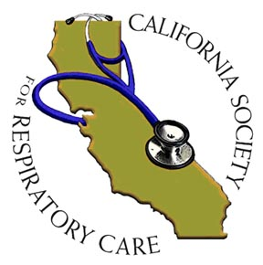

Released on: April 1, 2009, 9:47 am
Author: California Society for Respiratory Care
Industry: Healthcare
(Washington, DC) Respiratory therapist Paul Sherman, MS, RRT, RPFT, RCP went to Washington, DC March 8 2009, representing California Respiratory Care Practitioners, to ask members of Congress to allow Medicare patients with lung disease to have greater access to the services of a respiratory therapist.
Paul Sherman is a respiratory therapist at Santa Barbara Cottage Hospital and lives in Goleta, California.
Sherman met with Representatives Frank Wolf, James Moran, Senator Jim Webb, Carina Armenta of Senator Barbara Boxer’s office and Tim Gronniger, aid for Congressman Henry A. Waxman to ask their support for the Medicare Respiratory Therapy Initiative. Sherman plans to meet with Representative Lois Capps when she returns to her home district of Santa Barbara. Congressman Henry A. Waxman is the Chairman of the Energy and Commerce committee.
The Medicare Respiratory Therapy Initiative legislation will let patients more easily receive care in doctor’s offices from respiratory therapists, which is currently restricted under Medicare law. “Currently,” Sherman explains, “Medicare policy limits how patients can receive care from respiratory therapists, who are the expert caregivers for lung patients. We think that needs to change.”
Sherman is a member of the Political Advocacy Contact Team (PACT), a nationwide group organized by the American Association for Respiratory Care (AARC) to spearhead grassroots level advocacy efforts. Sherman is also a long time member of the California Society for Respiratory Care (CSRC) and has served in the past on the Board of Directors of the CSRC.
The California Society for Respiratory Care (CSRC), as an affiliate of the American Association of Respiratory Care (AARC), is a non-profit professional organization, whose mission is to represent and support our members through public and legislative advocacy, educational opportunities, and to continuously strive for excellence in the cardiopulmonary profession. By these means, the CSRC is committed to health, healing and disease prevention in the California community.
Contact: Abbie G. Rosenberg, RCP, RRT
Executive Director, CSRC
1961 Main street,
Suite 246 Watsonville, CA 95076
831-763-2772
arosenberg@csrc.org
www.csrc.org

