Los Angeles Invisalign


Released on: April 9, 2009, 2:54 am
Author: LPI
Industry: Healthcare
At Los Angeles Invisalign Orthodontists - there is effective and definitive treatment available to address your crooked or misaligned teeth or jaws. In Beverly Hills and Los Angeles you need Dr. David Alpan and his Aesthetic Orthodontics team. Aesthetic Orthodontics is your source for information on orthodontic alignment including the new option to traditional, visible braces: Invisalign.
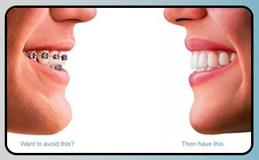
While many patients will still require the use of traditional braces to achieve optimal results,Invisalign is fast become a preferred option of treatment where possible. Invisalign does precisely what it name implies: It aligns teeth invisibly. Invisalign features a series of trays that are worn on the teeth. Each tray is used in sequence (changed every two weeks) and incrementally moves teeth into their ideal position. This process usually takes two years.
Traditional orthodontic treatment also can take up to two years, and sometimes longer for particularly complex cases, or cases involving mature patients (over the age of 25). Traditional orthodontic treatment may include the wearing of braces only, or may include surgical treatment. The exact staging of your treatment including any extraneous surgeries will be planned with Dr. Alpan, your general dentist and oral surgeon if necessary. If general dentist or oral surgeon services are required during this process, they will discuss their roles in your treatment specifically and offer you estimates for their aspect of the treatment.

Each treatment plan is designed according to each individual patient to address their needs and wishes. Your treatment plan may include:
1) The wearing of orthodontic brackets to move teeth into their ideal position;
2) Extraction of wisdom teeth: Wisdom teeth are known nuisances to ideal orthodontic alignment. There is the potential that they could affect successful alignment of teeth, or it may be that their removal will provide sufficient space to allow movement of the neighboring teeth. Wisdom teeth can also affect jaw alignment surgery;
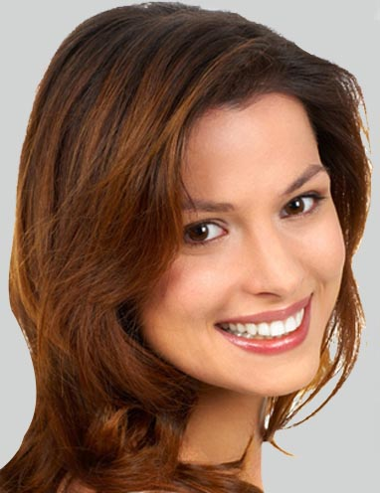
3) Jaw alignment surgery. If this is an option in your treatment, it will often be done at the same time as extraction of your wisdom teeth. This surgery is meant to set the upper and lower jaws in their optimal position in relation to each other. This helps establish a function and healthy bite while chewing and a better facial profile in cases of underbites and overbites;
4) Expansion appliances may also be necessary to expand the upper jaw so that teeth meet properly for chewing.
Many times orthodontic alignment is also a chance to fix certain structural and profile issues associated with the mouth, cheeks, and lips and other deformities. Perhaps this is one other reason you have decided to investigate orthodontic movement. If not, it is something that you should be aware of. Dr. Alpan can discuss all the potential outcomes and risks involved. If you have any questions whatsoever, please discuss them before deciding to go ahead with treatment. If over the course of treatment you have questions or concerns, do not hesitate to contact Aesthetic Orthodontics’ Los Angeles office.
Remember each treatment plan is client specific and can only be determined and developed upon consultation and visual and radiographic evaluation by Dr. David Alpan. Please schedule an invisalign consultation, today, to discuss your treatment options.
Los Angeles Invisalign - Invisalign Los Angeles, California
Contact Details: Aesthetic Orthodontics
2424 West Third St.
Los Angeles, CA 90057
(213) 785-2626
www.lainvisaligndentist.com

