MOLYKOTE® P-1900 Food Grade Paste Meets Food Contact Standards


Released on: April 29, 2009, 3:13 am
Author: RW Greeff
Industry: Industrial
Now available from industrial consumables specialist RW Greeff is Dow Corning’s Molykote® P-1900 Food Grade Paste - a specially-formulated anti-seize lubricant for applications in food and beverage processing plants.
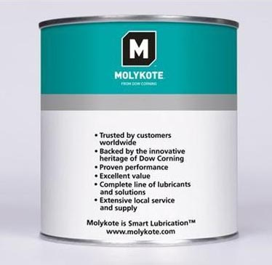
Molykote P-1900 can be used to lubricate sliding surfaces and friction contacts exposed to heavy loads, especially at low to medium speeds. It has a low coefficient of friction, good water resistance and high load carrying capacity. It has a service temperature range of –30º to 300ºC.
Molykote P-1900 also meets FDA regulations 21 CFR 178.3570 and NSF H1, making it ideal for use in food and beverage processing plants where incidental food contact may occur.
For more information please visitwww.rwgreeff.co.uk and search Molykote® P-1900
For more than 60 years, customers around the world have trusted the MOLYKOTE brand for performance and expertise to solve or prevent virtually any lubrication problem and to save energy through Smart Lubrication™.
As Dow Corning’s UK Channel Partner, RW Greeff provides a complete range of Molykote speciality lubricants with complimentary products from other world leading manufacturers. ISO 9001:2000 accredited, RW Greeff offers fast, reliable delivery to all areas of the UK & Ireland.
Contact Details: RW Greeff Head Office
Robert William Greeff House
Tame Park, Vanguard
Wilnecote, Tamworth
Staffordshire
B77 5DY
Tel: +44 (0) 1827 255 200
Fax: +44 (0) 1827 255 256
Email: rwgreeff@univareurope.com
http://www.rwgreeff.co.uk/lubricants/pastes/food-grade

