MacheteSoft Announces Release of Machete 3.2

Released on: April 14, 2009, 4:10 am
Author: MacheteSoft
Industry: Software
April 13, 2009 - MacheteSoft announces immediate availability of version 3.2 of Machete: Quick and Lean Video Editor.
Appreciated by customers worldwide as an ideal solution for easy yet very precise "slicing" of video files, Machete continues to add new functionality and enhance overall video editing experience. The new 3.2 version introduces several new features including:
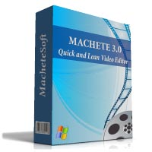
• Ability to edit WMA (ASF) audio files
• Ability to add/replace WMA audio stream in WMV (ASF) video files
• Improved shortcuts usability
Designed as a simple, fast as well as very powerful video editing tool, Machete does not require any special skills or advanced knowledge of digital video formats.
Machete 3.2 is immediately available and may be downloaded and purchased for $19.95 from http://www.machetesoft.com/Download-video-editor-Machete.html
The upgrade is free for all registered users of Machete.
Fully-functional trial version of Machete 3.2 can be used for 14 days after installation for thorough evaluation of the program.
Contact Details: Please contact MacheteSoft Sales at machete@machetesoft.com for further details.
For more information about Machete, please visit MacheteSoft home page http://www.machetesoft.com

