Miami Cosmetic Dentist Launches Patient Testimonial Video Gallery
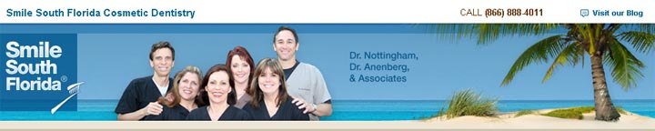
Released on: April 8, 2009, 1:00 am
Author: South Florida Dentist
Industry: Healthcare
Smile South Florida Cosmetic Dentistry is announcing the launch of its patient testimonial video gallery on its South Florida Dentist website, in addition to its smile gallery.
During its patient gratitude party, Smile South Florida's top cosmetic dentist patients shared their dental experience with the world. Miami Cosmetic Dentist patient, Mary, a former hygienist, says that she always looks at smiles and feels that smiles "bring out the beauty in people." She concluded her testimonial by saying: "I actually thought coming here was very relaxing... They make you feel at home and comfortable," she said.
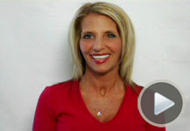
A Fort Lauderdale Cosmetic Dentist patient, Andrew, who is a business executive, explained that he interviewed many dentists, but their proposals were, in his words, "ridiculous... [and] outrageous." After interviewing some Smile South Florida patients, he was "very pleased with what [he] saw..." Andrew echoed the doctors advice: "The concept he was trying to tell me was, whereas I was interested in being well, what was happening was an improvement in my well being," he said.
The star at the patient gratitude party was ABC's Extreme Makeover Dental Labowners' mother, who is a Smile South Florida patient. She said, "For my son to send me here... it meant a lot to me.... You couldn't find a better doctor and you couldn't be in better hands...."
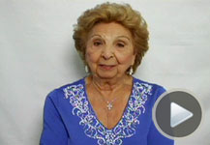
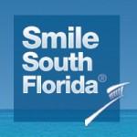
About Smile South Florida Cosmetic Dentistry
The cosmetic dentists at Smile South Florida Cosmetic Dentistry have offices in Broward County and West Palm Beach and provide patients Boca Raton Dentistry, Fort Lauderdale Dentistry and Miami Dentistry. The dentists specialize in dental aesthetics including porcelain veneers, dental implants, extreme makeovers Invisalign, and sedation dentistry.

About Dr. Charles Nottingham
Palm Beach Cosmetic Dentist, Boca Raton Cosmetic Dentist, & Fort Lauderdale Cosmetic Dentist Charles Nottingham, D.D.S., Fellow in the Academy of General Dentistry, is an internationally and nationally renowned cosmetic dentist. He has been creating dazzling, healthy smiles for his patients since 1974.
About Dr. Kenneth Anenberg
Besides being an excellent cosmetic dentist and restorative dentist, Dr. Anenberg specializes in Invisalign, a revolutionary alternative to metal braces, and Sedation-Sleep Dentistry.
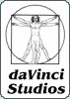
About da Vinci Dental Studios
DaVinci Studios (da Vinci Studios) is the dental lab service featured on ABC's Extreme Makeover and Fox's the Swan. For the last twenty years, our offices have been working with daVinci Studios to reconstruct thousands of smiles. Recently, we had the distinct honor of being selected by the owners of daVinci Studios to do a full mouth reconstruction on their mother.
Contact Details: Broward County Office
7401 N. University Dr., Ste. 207
Tamarac, FL 33321
Tel: (954) 721-6950
Fax: (954) 726-4292
http://www.smilesouthflorida.com

