Mobile application development company announces the release of shoes and handbag fashion apps for iPhone


Released on: April 21, 2009, 4:53 am
Author: Mobile App Studio (www.mobileappstudio.com)
Industry: Apparel & Fashion
iShoes and iBags apps expand availability of fashion-related content in popular Apple App Store
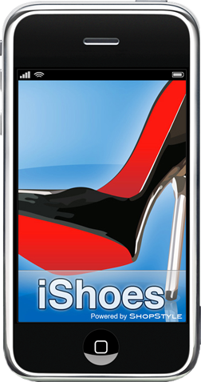
Mobile App Studio, developer of premium mobile applications for the iPhone and iPod Touch, announced today the release of the iShoes and iBags fashion apps on the Apple App Store. Following the successful launch of Apple's iPhone mobile platform last year, there are now over 30 million iPhones and iPod Touches in use today. Users of these devices can download applications to their phones that fit their interests and needs.
"There are over 35,000 apps available now on the Apple App Store, but one thing we've noticed is that very few of these apps are targeting women," said Carleen Ghio, co-founder of the Mobile App Studio. "As the iPhone market continues to expand, we wanted to ensure that fashion and shopping-related apps aimed at the female market are available on the Apple App Store to interest new users."
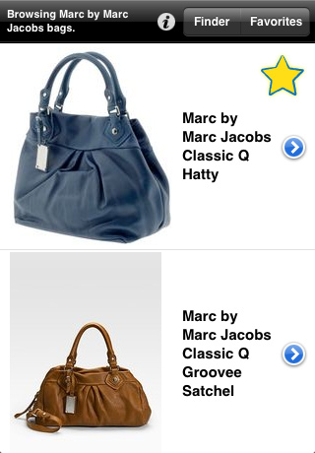
The iShoes and iBags applications give users the ability to entertain themselves by casually browsing shoes and handbags from their phones, leading to the discovery of new products and brands that interest them. They can also narrow their search to their favorite brands or a specific type of shoe or handbag when they have specific shopping needs. Users can add any products they see to their Favorites list, and then email this list to themselves or their friends.
The email option is key because it gives users the option to review their selected products later from their home computer, as browsing retailer websites and making purchases via mobile devices is not as easy as it is from a normal web browser. The focus on a single fashion product in each application, combined with simple navigation and browsing options, also makes the apps well suited for small mobile devices. There is even an offline mode available that allows users to download a set of shoes or handbags in advance and then browse them when on an airplane or out of range.
iShoes and iBags bring over 50,000 shoes and 20,000 handbags to the iPhone. The applications search hundreds of brands sold by over 100 retailers via ShopStyle.com. The products on display are constantly updated, allowing users to keep up with the latest styles available each season. iShoes and iBags are available as a free download on the Apple App Store.
About Mobile App Studio
Located in Crawfordville, FL, Mobile App Studio was founded in 2009 by Ryan Pream and Carleen Ghio. The Mobile App Studio develops premium lifestyle apps for the iPhone, iPod Touch and other mobile devices. All Software (C) 2009 Mobile App Studio / All Rights Reserved. Apple, the Apple logo, iPhone and iPod are registered trademarks of Apple Computer in the U.S. and/or other countries.
Contact Details:
Street Address: Crawfordville, Florida 32327
Phone Number: 707-294-1395
Email: mobileappstudio@gmail.com
Website: http://www.mobileappstudio.com

