Naartjie Announces the Arrival of Summer Two Fashions


Released on: April 24, 2009, 5:55 am
Author: Naartjie
Industry: Apparel & Fashion
Receive 25% off all online girls dresses and 25% off online boys fashion shorts
Salt Lake City, Utah, April 22, 2009 -- Naartjie, the original name in fashionable, kid-friendly clothing, announced today the arrival of its new, Summer Two line of clothing for infants and children. In addition, Naartjie is offering 25 percent off all online girls’ dresses and online boys fashion shorts through April 22, 2009.
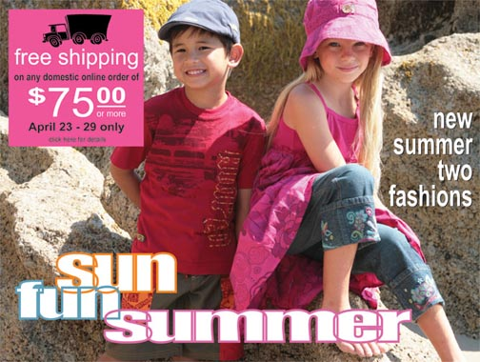
“Spring is here and summer is right around the corner and Naartjie is making a splash with new Summer Two looks for this season’s hottest kids styles,” said Joe Norwood, director of marketing, Naartjie USA. “As we make room for new items, we invite our online customers to take advantage f 25% savings off all girls dresses and all boys fashion shorts when they make purchases on our web site.”
Free spirited bohemian style inspires Naartjie girls’ Summer Two collection. Chunky crocheted lace trims, crinkled muslin fabrics and carved wooden buttons combine with casual loose fitting silhouettes to create the look. Dipped dyed muslin dresses and pants add to the hippie vibe. The line is comprised of three main prints inspired by beautiful Moroccan mosaics that are eclectically combined with our large “Eco Floral” print. The three prints mix and match in our $12 Necessities skirts and tanks create fun and easy outfits perfect for long summer days.
The Naartjie boy’s Summer Two line is inspired by South Africa’s surfing scene at Jeffery’s Bay. Graphics such as surfboards, waves, and palm trees combine with bold colors, crush dyed skulls, and checkered tees to give the line a punk rock edge. Color plays a very important part with a palette inspired by the reds and oranges of summer sunsets and the blue and green colors of the sea. Unexpected pops of neon orange and neon green add a splash of color and excitement inspired by summer.
For infants, Naartjie Summer Two features a “Fun in the Sea” boys’ newborn line starring Snorkeling Pup and his friend Booh, a mischievous practical joker. “Pretty in Plaid” blends bohemian plaids in shades of pink and purple combined with pretty Sundance floral to create our Boho newborn girl line. Feminine details such as embroidered eyelet, scalloped lace trims, and ruffled frills add sweetness and whimsy to the line.
Naartjie designs, colors, prints, and styles represent a truly unique synthesis of European fashion trends with western casual lifestyle. Featuring a dominant focus on natural fabrics that are garment-dyed, pre-washed and pre-shrunk for easy wear, low maintenance and comfort, Naartjie uses a garment dye process that results in a more vibrant color and softer clothing and accessories for precious little ones.
The ultimate in mix and match, Naartjie introduces new colors, prints and styles within a monthly grouping to allow customers to mix and match across the entire assortment. In addition, shoppers can mix and match between Naartjie collections, which showcase the freshest and broadest color assortment in the industry, distinctive detailing, mixing of fabrics, appliqués and embroidery details. Always “Kid-Friendly” design concepts made primarily of natural fabrics that feature weight-right fabrications for maximum comfort and easy care. Each item is designed and constructed for easy-wear comfort, whether the garment is dressed up or dressed down.
About Naartjie
Naartjie was founded in 1989 in Cape Town, South Africa when designer Anne Eales sought an alternative to the limited selection of childrens clothes available as she shopped for her three young boys. From its very conception, Naartjie was about KIDS… playful, vibrant, active, colorful, natural, always changing. We offer great kids clothes and baby clothes, basics and accessories for girls, boys, and newborns to 10 years of age -- all at surprisingly affordable prices. Naartjie’s corporate headquarters are located in Salt Lake City, Utah. Naartjie owns and operates stores in both the United States and South Africa, with new stores opening regularly. For more information, please visit us at http://naartjie.com.
# # #
Contact Details: Joe Norwood
Naartjie
2369 West Orton Circle
Salt Lake City, UT 84119
801-977-7790

