New Belden Brilliance Low Loss Plenum RG-11 Precision Digital Video Coax Significantly Improves Long-Distance Performance

Released on: April 21, 2009, 4:28 am
Author: Belden
Industry: Electronics
RICHMOND, IN - Belden (NYSE: BDC), a world leader in the development of signal transmission solutions for the enterprise, industrial, building management, broadcast, and security markets, announces the launch of its new and improved Plenum-rated RG-11 Precision Digital Video Coaxial Cable ? Product No 7732LL. Market applications for the new plenum cable include television broadcast studios, TV and video production, post-production facilities and field applications, HD-for-film production, video editing, distribution and duplication.
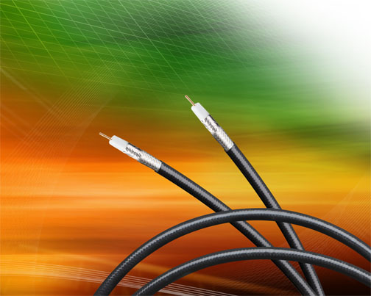
The new 7732LL cable offers significant performance enhancements over Belden's previous plenum-rated version (Product No 7732A), especially when deployed in long cable runs for high definition video (HD-SDI) or 1080p/60 applications. In fact, Brilliance 7732LL now offers the longest transmission distance in the industry, matching the performance of Belden's non-plenum SDI/HDTV Digital Video cables (7731A). In addition, Belden's 7732LL cables carry Belden's industry-leading Return Loss guarantee of: -23 dB 5 MHz to 1.6 MHz, and -21 dB from 1.6 GHz to 4.5 GHz ? making it the only plenum RG-11 cable in the industry with this level of guaranteed Return Loss performance.
Steve Lampen, Belden's Multimedia Technology Manager, notes: "The new Brilliance 7732LL cable represents a breakthrough development in extending the signal transmission distance of plenum-rated copper video cables, without having to install fiber optic cabling. As digital video progressed from SDI to HD-SDI and now to 1080p/60 and 1080p/50 (3G), these applications have placed greater length constraints on copper cables, especially plenum-rated. With this new product, the distance differential between plenum and non-plenum cables has been eliminated."
The new Belden Brilliance Plenum-Rated RG-11/U Type Precision Digital Video Coaxial Cables feature a 14 AWG solid bare copper conductor, Duofoil + 95% Tinned Copper Braid Shield, PTFE insulation and fluorocopolymer jacket. They are available in ten colors, including Black, Brown, Red, Orange, Yellow, Green, Blue, Violet, Gray and Natural.
For more information about Belden Brilliance 7732LL Low Loss Plenum RG-11 Precision Digital Video Coax, contact Belden at P.O. Box 1980, Richmond, Indiana 47375, 1.800.BELDEN.1. FAX: 765.983.5294. Or visit our Web site: http://www.belden.com.
About Belden
Belden is a customer focused company. We ensure that our customers' communications infrastructure issues are resolved and that they benefit from the best signal transmission performance for their investment. We deliver leading-edge copper and fiber cabling/connectivity systems, wireless technologies, and active switch devices. We employ customer-centric go-to-market strategies and we implement and retain world class manufacturing processes. Our partners span the globe, helping our customers design, install, operate and maintain their communications applications. And our experience is vast, including expertise in Enterprise, Industrial, Infrastructure, Transportation, Professional and Enterprise Audio and Video, and Government applications. To obtain additional information contact Investor Relations at 314-854-8054, or visit our website at http://www.belden.com.

