New Report Documents High Use of Refund Anticipation Loans in Native American Communities
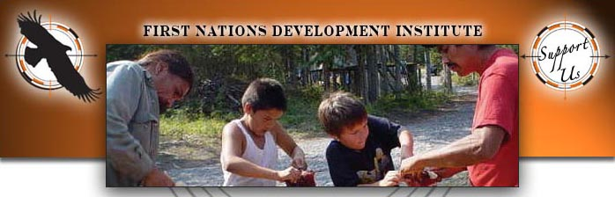

Released on: April 30, 2009, 5:40 am
Author: First Nations Development Institute
Industry: Non Profit
Refund Anticipation Loans cost EITC filers in Native communities over $9,100,000 in 2005.
Longmont, Colorado- Tax day has come and gone, and this year many people opted to get their tax refund a quick but expensive way: they took out a Refund Anticipation Loan. A Refund Anticipation Loan (or RAL) is a one to two week loan made by banks on behalf of filers, facilitated by tax preparers, and secured by a taxpayer’s expected tax refund. RALs are marketed as a way to “get your money quickly” and result in the users paying substantial fees to access their tax refund usually only five to ten days faster than for tax returns filed electronically. The average expense of the one to two week loan can be the equivalent of 50 to 500 percent APR, depending on the total fee and loan term. According to a report just released by First Nations Development Institute and the Center for Responsible Lending, Refund Anticipation Loans drained over $9,100,000 from Native American communities in 2005.
First Nations Development Institute and the Center for Responsible Lending’s report Borrowed Time: Use of Refund Anticipation Loans Among EITC Filers in Native American Communities documents the use of these costly loan programs on reservations and in other Native American communities. Researchers looked at the use of Refund Anticipation Loans in ten states with high Native American populations, and found that residents in counties with a large Native American population (such as counties with reservations in their boundaries) were more likely to take out Refund Anticipation Loans than residents of other counties. This is true despite the remote rural location of many of these counties, where there are few tax preparation businesses. In South Dakota, residents of counties with a high Native American population are five times as likely to take out a Refund Anticipation Loan. In North Dakota, residents of counties with a high Native American population are 11 times as likely to take out a Refund Anticipation Loan.
Most striking is the fact that the use of RALs is quite high among tax filers receiving the Earned Income Tax Credit in Native communities. The Earned Income Tax Credit was originally designed to supplement the earnings of low-to-moderate income families, and in 2009 a family of four could qualify for up to $4,824 in tax credits. Borrowed Time: Use of Refund Anticipation Loans Among EITC Filers in Native American Communities documents that in some Native communities, over seven out of every ten EITC filers received a RAL. In one county in South Dakota, nine out of every ten EITC filers received a RAL. In South Dakota, 8% of every EITC credit in Native communities was spent on taking out a RAL. This means that eight cents of every $1.00 of EITC credit in Native communities was diverted from its original target, working families, and instead went into the pockets of paid tax preparers.
Because Refund Anticipation Loans have a significant cost for Native communities, Borrowed Time: Use of Refund Anticipation Loans Among EITC Filers in Native American Communities provides recommendations for reducing their use. The first recommendation is to increase and support Volunteer Income Tax Assistance (VITA) sites in and near Native communities to allow filers to access free tax preparation services. In many cases, EITC filers and other filers may simply not be aware that they can access their tax refund without using a RAL. The authors of the report also recommend establishing an interest rate cap for RALs, and conducting public education campaigns in Native communities to encourage people to avoid paying high fees for RALs.
This landmark report is the result of a research study conducted under a grant funded by the Annie E. Casey Foundation. For more information about this publication, contact Sarah Dewees, Director of Research for First Nations Development Institute, at 540-907-6247 / sdewees@firstnations.org; or visit First Nations Development Institute’s website at www.firstnations.org to download a free copy of the paper.
Through a three-pronged strategy of Educating Grassroots Practitioners, Advocating Systemic Change, and Capitalizing Indian Communities, First Nations is working to restore Native control and culturally-compatible stewardship of the assets they own - be they land, human potential, cultural heritage, or natural resources - and to establish new assets for ensuring the long-term vitality of Native communities.
###
Media Contact: Sarah Dewees
Director of Research
First Nations Development Institute
2217 Princess Anne St.
Ste 111-1
Fredericksburg, VA 22401
Phone: 540-907-6247
e-mail: sdewees@firstnations.org

