Pop Princess Kylie Reveals Her Age-Defying Botox Secret


Released on: April 6, 2009, 2:33 am
Author: The Hospital Group
Industry: Healthcare
She has long been known for her age-less looks, but Kylie has finally revealed the secret of her vitality - regular Botox injections. The pint-sized popstress admitted the secret behind her youthful looks was Botox and other age-defying treatments.
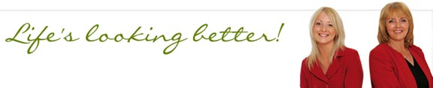
In an interview with Elle magazine, the 40-year-old said: “I’ve tried Botox, I’ve tried them all. I’m definitely not one of those people who says ‘You shouldn’t do this.’ Everyone individually can do what they want. I also think it doesn’t have the stigma that it had when I was growing up.
“For all time women have wanted to, for the most part, look their best. It’s just that what we have available to us today is – what it is today. And if you want to take advantage of it, yeah.”
Kylie’s perfect complexion has sparked many rumours over the years. One cosmetic surgeon has publicly claimed that, in their opinion, as well as Botox, she has had her cheeks and lips cosmetically enhanced.

The Hospital Group, the UK’s leading cosmetic surgery provider, performs many non-surgical age-defying treatments at its clinics, including Botox anti-wrinkle treatment, facial fillers, skin peels, hyperhidrosis and mole removal.
Kylie’s revelation has provoked commentators to point out her seemingly frozen forehead and eyebrows. However, The Hospital Group’s Juvéderm facial fillers plump up the appearance of laughter lines, frown lines and other wrinkles for the more natural look when used alongside Botox anti-wrinkle treatment.
As well as these non-surgical procedures, The Hospital Group performs other age-defying surgical treatments such as face and brow lifts. Other surgical procedures such as rhinoplasty, otoplasty, eyebag removal and eye lifts complete The Hospital Group’s age-beating treatments.
Since The Hospital Group was established in 1992, it has grown from a small pharmaceutical company to one of the UK’s foremost cosmetic surgery providers. The Group is committed to providing the very highest standards and all procedures are performed by an expert medical team in state-of-the-art facilities that are second to none.
For further information or case study details please contact
Lucy Kemp, Felicity Cross or Chris Brown at Seal on 0121 616 5800.

