Proshield Provides Warning Signs That Lead to Increased Public Safety
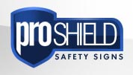

Released on: April 23, 2009, 4:11 am
Author: proshieldsafetysigns.co.uk
Industry: Industrial
Wakefield, West Yorkshire - Proshield provides a variety of safety signs that makes it one of the leading sign seller in the U.K. The safety of others remains Proshield's main goal for its business. Protecting several pedestrians and drivers from hazardous conditions, Proshield signs also help provide communities with a sense of security.
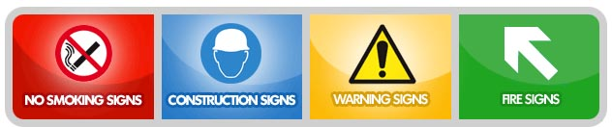
Not only does Proshield provide a variety of signs, but also guides buyers on how to select and order signs with their sign buying guide. An important resource for a customer of Proshield, this guide first explains how to choose a sign, choose the material to make it from (6 types to choose from) and the size of the sign (23 sizes to choose from). Ultimately, this how-to guide helps customers to remain satisfied and to come to ProShield time and time again.
Proshield provides a rapid delivery service helping to keep communities safer and in a spedfast manner. They also recognize the important of providing a large variety of signs, so that you can depend on them for all of your sign needs. Some of the signs that Proshield offers include:
A. No Smoking Signs
B. Fire Safety Signs
C. Warning Signs
D. Health Safety Signs
E. Fire Exit Signs
F. UK Safety Signs
G. Custom-made Signs
H. Road Safety Signs
I. Hazard Signs
J. Braille Signs
K. CCTV Signs
L. Construction Safety Signs
Proshield provides a simple online service of purchasing custom-made signs for your business or community. Never has customization been easier, not only with their how-to guide, but with the help of their employees whom are willing to help you along the way. Proshield remains a convenient seller for many!
Unlike other sign sellers that require a minimum purchase, Proshield recognizes each order's needs are different. Thus, there is no minimum order charge. This makes it more convenient to purchase signs as you need them, not when you have a large enough order to process. This makes safety easier for all businesses and communities with no stalling, just continued safety through the purchase of hazard, warning or construction safety signs.
The material a sign is made of is an important option. Proshield offers six different options:
A. Photo luminescent Adhesive Vinyl (LSV)
B. Photo luminescent Rigid Plastic (LRP)
C. Rigid Plastic (RPL)
D. Self Adhesive Vinyl (SAV)
E. Aluminum (ALU)
F. Polycarbonate (PLY)
With the experts at Proshield, you can determine the perfect material for each sign you desire to purchase. Ultimately, with a comprehensive website as well as intelligent and helpful customer service, any person can effectively purchase professional hazard and warning signs from Proshield. Countless satisfied customers can agree! Try Proshield today.
For more information on warning signs, visit Proshield's official website, Proshieldsafetysigns.co.uk. There you will find a variety of sign options including safety signs as well as custom-made signs options.
Contact Details: Proshield Safety Ltd
http://www.proshieldsafetysigns.co.uk
Proshield Safety Ltd
26 Cheapside
Wakefield
West Yorkshire
WF1 2TF
Tel: 0845 678 5556
Email: info@proshieldsafetysigns.co.uk

