Seamlessweb Launches Mobile Site For Ordering On-The-Go

SeamlessWeb Users Can Now Browse and Order from Local Restaurants Via Mobile Phones


Released on: April 27, 2009, 2:34 am
Author: SeamlessWeb
Industry: Food & Beverage
NEW YORK, N.Y. — April 27, 2009 –¬– SeamlessWeb, the nation’s leading online food ordering service, today announced the launch of its mobile Web site and iPhone Web App. The SeamlessWeb mobile site, available on any Web-enabled mobile device atwww.seamlessweb.com, allows SeamlessWeb’s hundreds of thousands of hungry users to view menus and order meals from more than 3,500 restaurants in over 22 cities. The site was developed in response to high demand from SeamlessWeb customers for the ability to order food on-the-go.
Users can now log into existing accounts or create a new account from their mobile device and take advantage of the same features and functionality as the original Web site, including:
• Viewing up-to-date menus from 2,500+ restaurants in 14 cities
• Finding and sort through restaurants that deliver to your address
• Paying and tip by credit card
• Re-ordering favorite meals in just two clicks
“The ability to order food on mobile phones allows our customers to take advantage of the convenience of ordering food through SeamlessWeb whenever hunger strikes,” said Jason Finger, co-founder and CEO of SeamlessWeb. “Customers now have the ability to use our site wherever they are, breaking the barrier for those without access to a computer and further saving time from traditional food ordering methods.”
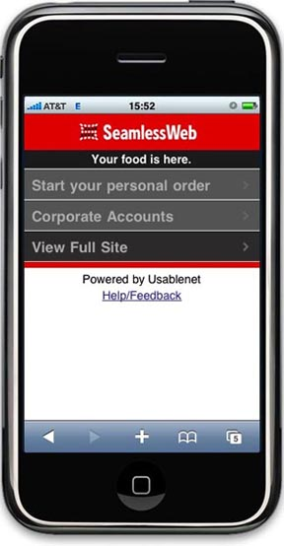
Users can also access the mobile site from any desktop or PC by visitingwww.seamlessweb2go.com. SeamlessWeb’s mobile site is powered by Usablenet, a mobile partner for other leading brands, including American Airlines, Amtrak, Limited Brands, Marriott Hotels, Nissan and Pfizer.
About SeamlessWeb
SeamlessWeb is a comprehensive, web-based food ordering system that links companies and individuals with local restaurants, caterers and onsite dining providers. SeamlessWeb was founded in 1999 with the mission of providing companies, customers, and restaurants with an efficient and cost-effective method of purchasing and accounting for food. Since then, SeamlessWeb has become the industry leader in online food ordering, processing almost 1.5 million orders per month, and now services over 3,500 clients, 3,000 restaurant partners and over 500,000 individual users in cities throughout the U.S. and London.
About Usablenet
Usablenet’s unique mobile Web platform provides leading brands with a new channel to extend marketing, commerce and client service efforts to their customers. It offers companies a fully managed service called Usablenet Mobile that translates all existing Web site functionality to a full-featured mobile interface. The solution requires no IT or Web resources on the client side, works on all Web-enabled mobile devices worldwide and can be implemented in six weeks. Usablenet customers include American Airlines, Amtrak, Limited Brands, Marriott Hotels, Nissan and Pfizer. Founded in 2000, Usablenet is a private company headquartered in New York City with offices in Italy. For more information, visit www.usablenet.com
Contact:
SeamlessWeb
Matt Johnson
646-666-2029
mjohnson@seamlessweb.com
Usablenet
Jeremy Frank
212-564-3665
usablenet@launchsquad.com

