SteroidSources.com Offers Free Membership To Online Forum
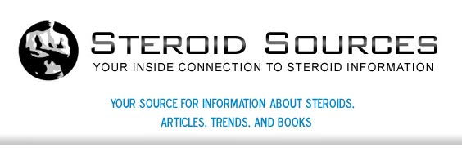

Released on: April 29, 2009, 3:31 am
Author: Steroidsources.com
Industry: Healthcare
St. Petersburg, Florida, April, 2009 -- The popular website SteroidSources.com provides free forum access to individuals searching for relevant steroid information. The forum makes it easy to connect with like-minded people, learn more about the proper use of anabolic steroids, and discuss personal experiences with the different steroid products available on the market.

The Steroid Sources forum lets visitors communicate with other members of the site and participate in discussions on a wide range of topics. It's the best place to discuss how and where to buy steroids, as well as a variety of different issues related to the use and abuse of performance-enhancing drugs.
In addition, the forum contains a large amount of information pertaining to specific products, including dianabol, anadrol, deca-durabolin, winstrol-v, and sustanon. Forum topics even provide registered members with insider information on steroid scammers, bodybuilding tips, diet and nutrition, and female-specific issues.
SteroidSources.com provides relevant and objective information on the safe use of steroids, and features extensive resources and articles for those with previous experience using anabolic steroids and related products. The website also helps visitors learn how to find anabolic steroids for sale and buy steroids online.
Steroid use is a topic that is still up for debate in most circles, especially as it relates to sports performance and athletes. Although controversial in the world of sport, most anabolic steroid products are prescribed to treat a variety of different medical disorders, such as asthma and cancer.
As far as steroid use pertains to professional sports, the experts have not yet reached a consensus. Because steroid use in the sporting industry continues to increase, the debate may one day reach a final conclusion.
Currently, it's illegal to buy steroids without a prescription. However, individuals with a prescription from their doctor are permitted to buy anabolic steroids for personal use. The Internet has made it easy to purchase the drugs you need from the comfort of your own home.
For more information about anabolic steroids, contact Steroid Sources or visit http://www.steroidsources.com.
About SteroidSources.com: SteroidSources.com is a popular website that offers visitors interesting and relevant information, resources, and news on the topic of anabolic steroid. Thesite also provides a forum where like-minded individuals can meet to discuss issues, obtain advice, and swap personal experiences and stories or buy steroids.
Contact Details: http://steroidsources.com/
SS, Inc.
22nd Avenue
P. O. Box 530007
St. Petersburg, FL 33747

