Steroidsources.com Has Answers Regarding Anabolic Steroids
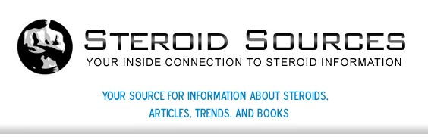

Released on: April 29, 2009, 3:19 am
Author: Steroidsources.com
Industry: Healthcare
Mesa, AZ, April, 2009/PressRelease/: Steroidsources.com has launched a website to help consumers discern the good from the bad, and truths from the lies. With so many professional athletes coming under fire the last few years for steroid use, questions about anabolic steroids are getting asked and many are finding they do not have access to a trustworthy source. Steroidsources.com has news, blogs, forums, articles and also offers book and videos on the subject of steroid use and its users.

Steroidsources.com wants to bring the body building community together to discuss the latest trends in fitness, health, and steroids. Steroidsources.com is a website dedicated to news and information about steroids. Updated with important breaking news regarding steroids and athletes who take them, medical uses for steroids, the benefit of steroid use in body-building, and the health hazards to using steroids as a performance enhancer, Steroidsources.com is the online information guide to steroids.
Steroidsources.com has a forum for individuals with questions or information that can be posted to get the answers that are needed. Blogs for updated information in the body building community that lets each other know what is going on in regards to supplements, testing, and new performance enhancers. There are also top selling books and videos about on the subject of steroids and fitness. Searching the internet for information regarding legal steroids can lead to websites that have less than honorable intentions. SteroidsSource.com is a safe website to discuss steroids and the pros and cons.
Steroidsources.com focuses on news and trends in the body building community and sporting arena, serving its purpose in letting people find fair, accurate information regarding steroids, their use, and their side effects. Steroidsources.com is not where to go if the purpose is to buy steroids. SteroidSources.comhopes to build a strong community amongst fitness enthusiasts, body builders, and athletes alike. SteroidSources.com wants to showcase the ups and downs of fitness training, the use of anabolic steroids and other performance enhancing drugs.
Recently founded SteroidSources.com offers forums, blogs, news, and other media to keep you up to date in current trends in fitness, health, and body building.
For questions or comments please refer to the contact page at SteroidSources.com.
Contact Details: http://steroidsources.com/
SS, Inc.
22nd Avenue
P. O. Box 530007
St. Petersburg, FL 33747

