SurgiCare introduces new Vaser Lipo Cosmetic Treatment
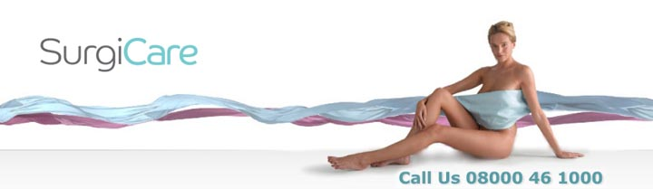

Released on: April 14, 2009, 6:03 am
Author: SurgiCare
Industry: Healthcare
SurgiCare introduces new Vaser Lipo procedure in response to a huge rise in SmartLipo enquiries, as people get into summer mode and want to look good on the beach.
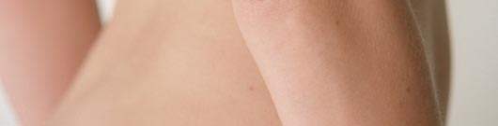
Following a first quarter year on year increase of 375% in the number of enquiries forSmartLipo through Surgicare, the cosmetic surgery network has announced the introduction of their new Vaser Lipo procedure.
SurgiCare's current SmartLipo procedure is a revolutionary concept in fat removal, using laser technology to melt fat cells and provide immediately visible results. The introduction of Vaser Lipo technology leads to more selective and gentle procedure that reduces possible swelling and bruising, producing a shorter recovery period.
Liposuction has been around as a favourite body contouring surgical procedure since the 1980s, however a few years ago the technique of SmartLipo, was introduced as a form of Liposuction without the suction to help reduce recovery times. SmartLipo uses a fine fibre optic laser to break up fat deposits which are then gradually reabsorbed by the body over the next 6 to 12 weeks.
Vaser, which stands for Vibration Amplification of Sound Energy at Resonance, is an ultrasound assisted form of Liposuction developed by Sound Surgical Technologies in Utah. Vaser utilizes fine probes which include engineered grooves to help control and restrict the effects of the ultrasound to targeting just the fat and not the surrounding cells, as well as reducing any potential bleeding.
Mark Bury, CEO at Surgicare, said, "Surgicare is always looking for ways to improve patient care and reduce recovery times. The introduction of the new Vaser Lipo procedure will mean even better results for patient and represents a major step forward. With the increase in the number of enquiries which we have already received for SmartLipo procedures this year, we expect to be very busy in the run up to the summer holidays."
About SurgiCare
SurgiCare is one of the largest and most respected cosmetic surgery networks in the UK. SurgiCare was established more than 16 years ago by a leading professor of surgery, now its medical director, who also chairs its in-house Medical Advisory Committee.
As one of the leading UK specialists in cosmetic treatments, SurgiCare has the experience, latest therapies and the caring, professional staff to enhance a patients self-confidence by improving appearances. SurgiCare prides itself on providing an unrivalled aftercare service with all surgeons registered on the General Medical Council Specialist Register, to ensure every patient receives the best possible standard in care and results.
SurgiCare has helped more than 20,000 patients fulfil their dreams of looking and feeling their best. SurgiCare also specialise in Weight Loss Surgery with a unique 24 month support programme and lifetime aftercare.
PR contact:
Gemma Gore
Tangerine PR
Giants basin
Potato Wharf
Manchester
M3 4NB
0161 817 6600
www.surgicare.co.uk

