USBSwiper.com, True Wireless Credit Card Processing

Allows Businesses to Affordably SWIPE and Process Credit Cards Out In The Field Using only a Customer’s Laptop And an Internet Connection, Seeks to Create New National Sales Force – USBSwiper.com attends National Career Job Fairs Nationwide.


Released on: April 17, 2009, 5:02 am
Author: Richard J. Freedkin
Industry: Small Business
Newly-developed USBSwiper offers Customers the unique opportunity to simply, easily and securely process customer credit cards with true mobility. Customers can simplify their businesses by being able to swipe credit cards anywhere whether at their store location or out in the field using only the customers Laptop, Internet Connection, USBSwiper software interface and magnetic card reader and the PayPal merchant processing system.
Chicago, IL (April 16, 2009) – Richard Freedkin was a small business owner with a big problem. As a Real Estate investor and consultant who traveled the country conducting seminars and selling his books, he was wasting time and losing business whenever he typed in customers’ credit card information into PayPal’s virtual terminal by hand at each of his workshops. He needed a simple way to swipe credit cards at any seminar or convention location with only his internet connection and laptop.
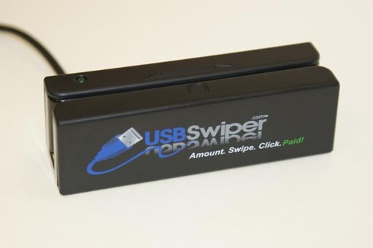
When he asked developers in an online forum about available credit card swipers that were compatible with PayPal, everyone said it couldn’t be done except for 25-year-old Drew Angell, a certified PayPal ACE developer. Just over 6 months later, the pair founded AngellFree, Inc., and officially unveiled the only PayPal compatible credit card swiping solution at the annual Ebay Live! event in Chicago.
“I needed a product like this for my business, and thousands of other business people also need and are looking for something like this too. Other Wireless or Mobile Credit Card Solutions are just too expensive,” said Freedkin. “It was a situation where necessity was the mother of invention. Because of USBSwiper, I can now process payments for 30 to 40 of my books in just a few minutes and I have all of my reports and records centralized in one place. The best part is that unlike other merchant credit card processors, the money is deposited into my account instantly.”
The USBSwiper software, along with USBSwiper’s compatible magnetic card reader, can be used on both Mac and PC platforms. Unlike applying for and using merchant credit card processors, using USBSwiper in conjunction with PayPal will save small business owners merchant credit card processor fees, paperwork, time, lost interest, and lost fees during refund transactions.
“All you need is a computer with an internet connection and you’re set to go,” said Freedkin. “We’ve seen USBSwiper utilized by kiosk owners, microbreweries, artists, airport curbside checkers, taxi cab companies, and flea market sellers. The applications are endless for the small business owner, especially if you sell products either online, from a storefront, or in person at a customer’s home such as a home improvement or HVAC company. There are virtually thousands of different applications that this will work for inexpensively. Now everyone can enjoy true affordable wireless credit card processing”
The Word is spreading said Angell. “Everyone is so excited about this product, and it makes me feel great to know how much it’s already helped people out and to hear the positive feedback. I’m looking forward to introducing it to so many sellers who could truly benefit from it and grow their business.”
The True Wireless Mobility that this product offers has now sparked Freedkin and Angell to create a national sales force of Independent USBSwiper Representatives who will market the product Nationwide. According to Freedkin, “In this economic climate of Job losses and layoffs, many people are opening up small businesses. This opens up a huge opportunity for many people to create financial freedom by marketing this phenomenal product and to create a great residual income while at the same time, helping those businesses who have wanted to, but could not afford to have wireless credit card processing in the field before.”
For those who would like to learn more, please visit www.usbswiper.com.
About AngellFree Inc.:
Founded in 2008 and based out of Lake Zurich, Illinois, AngellFree, Inc., provides small business owners with web and application development solutions.
Contact Details: USBSwiper.com, 830 W. Rt. 22 #235, Lake Zurich, IL 60047 (224) 677-0283 Office, (847) 307-8464 Fax, Richard@USBSwiper.com, www.USBSwiper.com

